Table of Contents
Preamble | 1
Six Core Elements of Health Care Transition 2.0: Side-by-Side Version | 2
Six Core Elements of Health Care Transition 2.0: Transitioning Youth to an Adult Approach to Health Care Without Changing Providers | 4
Introduction to Each of the Six Core Elements | 5
Core Element Samples
- Transition Policy
- Sample Transition Policy | 6
- Transition Tracking and Monitoring
- Sample Individual Transition Flow Sheet | 7
- Sample Transition Registry | 8
- Transition Readiness
- Sample Transition Readiness Assessment for Youth/Young Adults | 9
- Sample Transition Readiness Assessment for Parents/Caregivers | 10
- Transition Planning/Integration into Adult Approach to Care
- Sample Plan of Care | 11
- Sample Medical Summary and Emergency Care Plan | 12
- Transfer to Adult Approach to Care
- Transfer Completion/Ongoing Care
- Sample Health Care Transition Feedback Survey for Youth/ Young Adults | 15
- Sample Health Care Transition Feedback Survey for Parents/Caregivers | 16
Measurement Approaches
- Current Assessment of Health Care Transition Activities | 17
- Health Care Transition Process Measurement Tool | 20
Six Core Elements of Health Care Transition 2.0
Transitioning to an Adult Approach to Health Care Without Changing Providers
for use by Family Medicine and Med-Peds Providers

Got Transition is pleased to share this updated package of the Six Core Elements of Health Care Transition for use by family medicine and med-peds providers to benefit all youth as they transition from a pediatric to an adult approach to health care. Consistent with the AAP/AAFP/ACP Clinical Report on Health Care Transition, transition consists of joint planning with youth to foster development of self-care skills and active participation in decision-making.
The Six Core Elements of Health Care Transition 2.0 define the basic components of health care transition support. The linked sample tools in this package provide tested means for transitioning youth to adult care. Originally developed in 2009, this updated version of the Six Core Elements incorporates the results of recent transition learning collaborative experiences in several states, an examination of transition innovations in the United States and abroad, and reviews by over 50 pediatric and adult health care professionals and youth and family experts.
We recognize that family medicine and med-peds providers play three distinct roles in the transition process. These roles include:
- providing developmentally appropriate care for youth and young adults who remain within the practice as they transition to an adult approach to health care,
- transitioning youth and young adults to different adult providers when they move or go away to college, and
- accepting and integrating new young adult patients who have transferred from other providers.
The tools in this package pertain only to this first role-- assisting youth and young adults who remain with the practice from childhood to adulthood and require transition support to be ready for an adult approach to care (e.g. managing their own care, understanding privacy and consent.) Corresponding transition packages are available for transitioning youth and young adults to different adult providers (#2 above) and accepting and integrating new young adult patients who have transferred from other providers (#3 above).
Recognizing and responding to the diversity among youth and their families is essential to the transition process. This diversity may include but is not limited to differences in culture, race, ethnicity, languages spoken, intellectual abilities, gender, sexual orientation, and age. Since implementation of the Six Core Elements depends so much on patient and provider communication, health plans and practices should use appropriate oral and written communications, including interpretation and translation services and health literacy supports as needed. In addition, engaging youth, young adults, and parents/caregivers from various cultural backgrounds in the development and evaluation of a transition quality improvement process is important.
To implement the Six Core Elements, a quality improvement approach is recommended. Plan-do-study-act (PDSA) cycles provide a useful way to incrementally adopt the Six Core Elements as a standard part of care for youth and young adults. The process begins with the creation of a collaborative team that could include physicians, nurse practitioners, physician assistants, nurses, social workers, care coordinators, medical assistants, administrative staff, IT staff, and young adult/young adults and families. Leadership support from the practice, plan, or academic department is critical as well. Oftentimes, practices decide to begin with a subset of young adult in order to pilot the pediatric and adult delivery system changes needed for transition. Sample tools that can be customized for use in primary and specialty care are available in this package and on www.GotTransition.org.
Got Transition has developed two different measurement approaches, described below, to assess the extent to which the Six Core Elements of Health Care Transition 2.0 are being incorporated into clinical processes. Both are aligned with the AAP/AAFP/ACP’s Clinical Report on Transition and the Six Core Elements.
- Current Assessment of Health Care Transition Activities. This is a qualitative self-assessment method that allows individual providers, practices, or networks to determine the level of health care transition support currently available to young adult transitioning from pediatric to adult health care. It is intended to provide a current snapshot of how far along a practice is in implementing the Six Core Elements.
- Health Care Transition Process Measurement Tool. This is an objective scoring method, with documentation specifications, that allows a practice or network to assess progress in implementing the Six Core Elements and, eventually, dissemination to all young adults ages 18 to 26. It is intended to be conducted at the start of a transition improvement initiative as a baseline measure and then repeated periodically to assess progress.
Got Transition welcomes your comments and feedback on the updated Six Core Elements of Health Care Transition 2.0. Please send your feedback to info@GotTransition.org. Thank you for your interest in the successful health care transitions of young adult and young adults from pediatric to an adult approach to care.

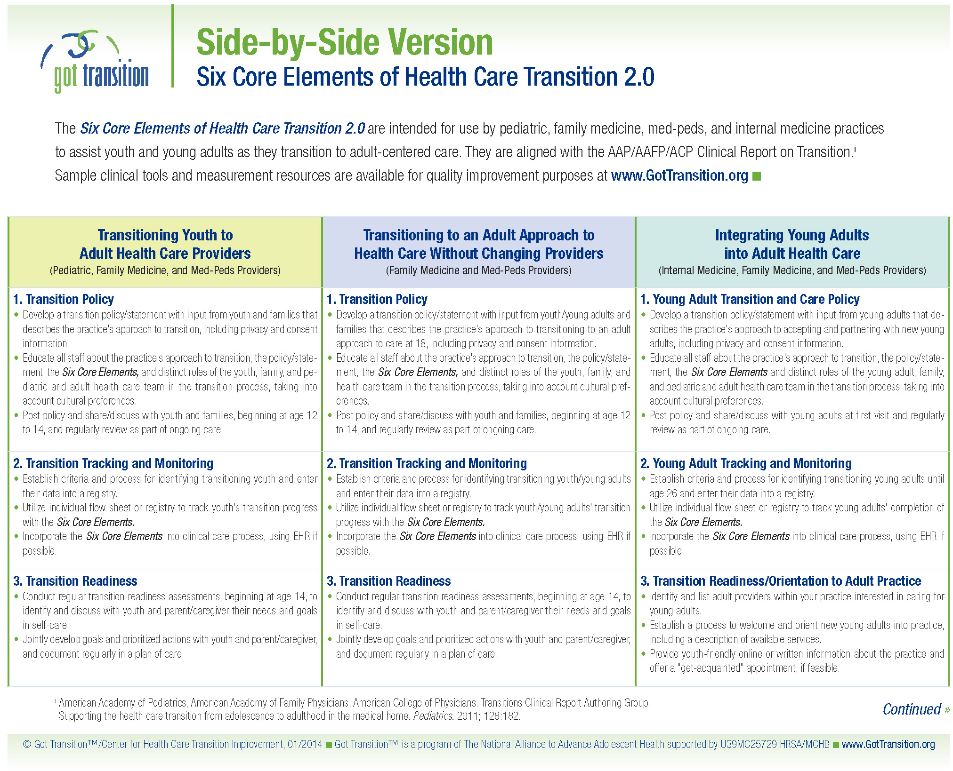

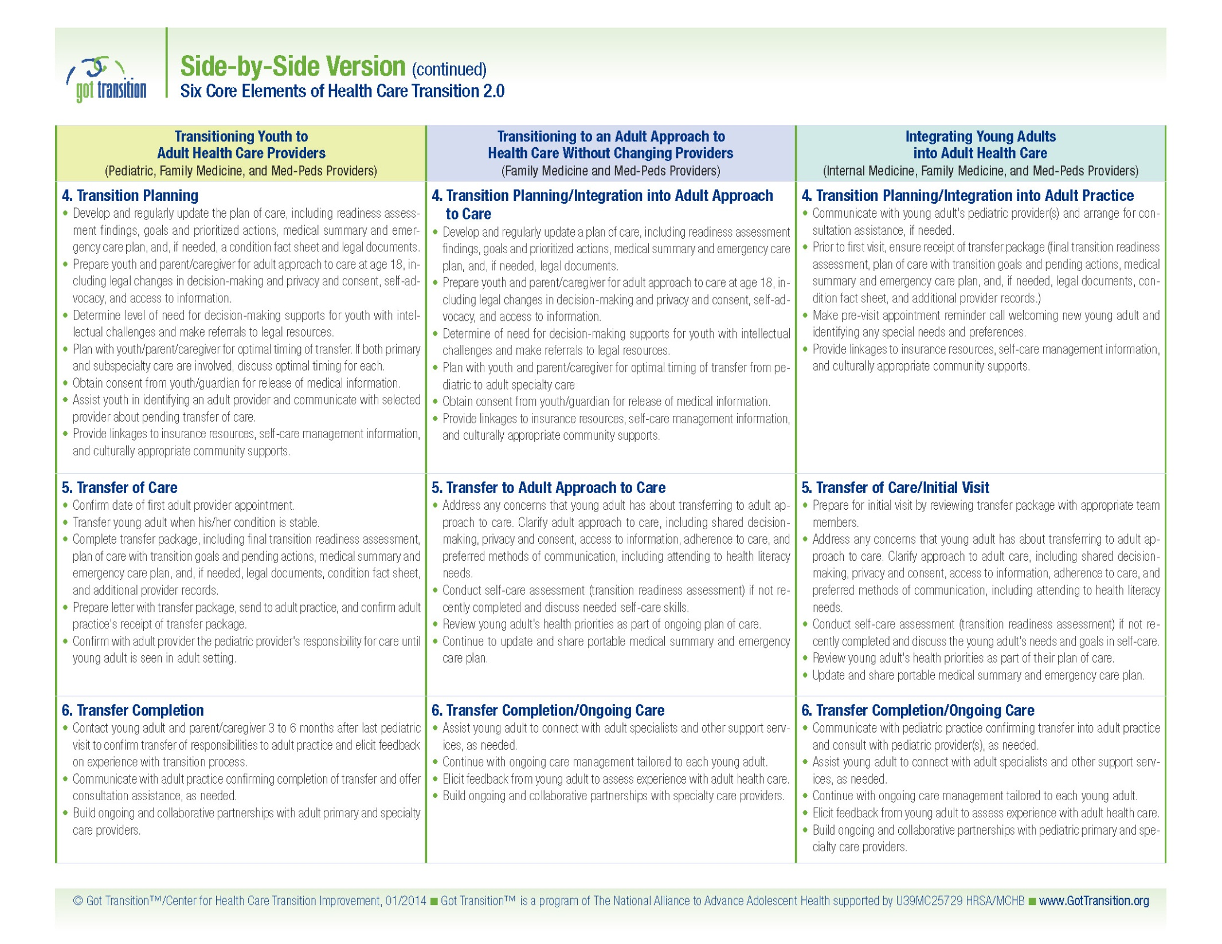

1. Transition Policy
- Develop a transition policy/statement with input from youth/young adults and families that describes the practice’s approach to transitioning to an adult approach to care at 18, including privacy and consent information.
- Educate all staff about the practice’s approach to transition, the policy/statement, the Six Core Elements, and distinct roles of the youth, family, and health care team in the transition process, taking into account cultural preferences.
- Post policy and share/discuss with youth and families, beginning at age 12 to 14, and regularly review as part of ongoing care.
2. Transition Tracking and Monitoring
- Establish criteria and process for identifying transitioning youth/young adults and enter their data into a registry.
- Utilize individual flow sheet or registry to track youth/young adults’ transition progress with the Six Core Elements.
- Incorporate Six Core Elements into clinical care process, using EHR if possible.
3. Transition Readiness
- Conduct regular transition readiness assessments, beginning at age 14, to identify and discuss with youth and parent/caregiver their needs and goals in self-care.
- Jointly develop goals and prioritized actions with youth and parent/caregiver, and document regularly in a plan of care.
4. Transition Planning/Integration into Adult Approach to Care
- Develop and regularly update a plan of care, including readiness assessment findings, goals and prioritized actions, medical summary and emergency care plan, and, if needed, legal documents.
- Prepare youth and parent/caregiver for adult approach to care at age 18, including legal changes in decision-making and privacy and consent, self-advocacy, and access to information.
- Determine of need for decision-making supports for youth with intellectual challenges and make referrals to legal resources.
- Plan with youth and parent/caregiver for optimal timing of transfer from pediatric to adult specialty care
- Obtain consent from youth/guardian for release of medical information.
- Provide linkages to insurance resources, self-care management information, and culturally appropriate community supports.

5. Transfer to Adult Approach to Care
- Address any concerns that young adult has about transferring to adult approach to care. Clarify adult approach to care, including shared decision-making, privacy and consent, access to information, adherence to care, and preferred methods of communication, including attending to health literacy needs.
- Conduct self-care assessment (transition readiness assessment) if not recently completed and discuss needed self-care skills.
- Review young adult’s health priorities as part of ongoing plan of care.
- Continue to update and share portable medical summary and emergency care plan.
6. Transfer Completion/Ongoing Care
- Assist young adult to connect with adult specialists and other support services, as needed.
- Continue with ongoing care management tailored to each young adult.
- Elicit feedback from young adult to assess experience with adult health care.
- Build ongoing and collaborative partnerships with specialty care providers.

- Transition Policy
Creating a written practice policy on transition is the first element in these health care transition quality recommendations. Developed by your practice or health system, with input from youth, families and young adults, the policy provides consensus among the practice staff, mutual understanding of the process involved, and a structure for evaluation. The policy should include the practice’s approach to partnering with youth to develop independence and self-care skills. It should also explain the legal changes that take place in privacy and consent at age 18. The policy should be shared with youth and families beginning at ages 12 to 14 and publicly posted.
- Transition Tracking and Monitoring
Establishing a mechanism to track progress of youth and young adults as they receive the Six Core Elements is the second element in these health care transition quality recommendations. An individual flow sheet within the chart or EHR can be used to track individual patient progress with the Six Core Elements. Information from an individual flow sheet can be used to populate a registry and help to monitor the transition progress within a larger population. Practices may elect to start monitoring transition progress with a subset of youth and young adults with chronic conditions. The long-term goal is to track health care transition progress among all youth ages 12 and older, with and without chronic conditions.
- Transition Readiness
Assessing youth’s readiness to transition to an adult approach to care is the third element in these health care transition quality recommendations. Use of a standardized transition/self-care assessment tool is helpful in engaging youth and families in setting health priorities, addressing self-care needs to prepare them for an adult approach to care at age 18, and navigating the adult health care system, including health insurance. Providers can use the results to jointly develop a plan of care with youth and families. Transition readiness/self-care assessment should begin at age 14 and continue through adolescence and young adulthood, as needed.
- Transition Planning/Integration into Adult Approach to Care
Planning for transition as a collaborative and continuous process with youth and families is the fourth element in these health care transition recommendations. It encompasses several activities. To begin with, it is important to develop and regularly update a plan of care that identifies the youth’s priorities and addresses how learning about health and health care can support their priorities. In addition, to further youth’s independence, developing and sharing a medical summary and emergency care plan and establishing linkages to community-based supports is also important. Starting at about age 16, providers should assist youth and families in preparing for changes in decision-making when youth legally become adults at age 18. For some youth and families this may require referring them to legal resources about supported decision-making, and for others it may require obtaining their consent to involve parents/caregivers. In addition, transition planning involves inquiring about youth’s preferences for transferring to adult specialty providers and assisting them in this process.
- Transfer to Adult Approach to Care
Changing to an adult model of care at age 18 is the fifth element in these health care transition quality recommendations. The provider should continue to work with the young adult to provider confidential services, assess and strengthen self-care skills, develop a plan of care, and update and share a medical summary and emergency care plan.
- Transfer Completion/Ongoing Care
Coordinating transfer to adult specialists, as needed, and assessing young adult experience with transition support are the final element in these health care transition quality recommendations. To evaluate the success of the transition process and the young adult’s experience with care, having a mechanism to obtain and incorporate the feedback will improve the practice’s approach to transitioning to an adult approach to care.

[Practice Name] is committed to helping our pediatric patients become better prepared for an adult model of health care at age 18 to continue on with our practice as young adults. At about age 14 we will begin to spend time during the visit without the parent present in order to answer questions, set health goals, and support increasing independence with health care. At age 18, youth legally become adults. We respect that many of our young adult patients choose to continue to involve their families in health care decisions. However, we will no longer be allowed to discuss anything with parents about care or share any personal health information without the young adult’s written consent. To allow others to be involved in health care decisions requires that a signed consent form be completed, which we have at the clinic. If an adolescent has a condition that prevents him/her from making decisions, we encourage families to consider options for supported decision-making. Your health is important to us. If you have any questions or concerns, please feel free to contact us.

Patient Name: ______________ Date of Birth: ___________

Primary Diagnosis: ______________

Transition Policy
-Practice policy on transition discussed/shared with youth and parent caregiver _________
Date
Transition Readiness Assessment
-Conducted transition readiness assessment _________ _________ _________
Date Date Date
-Included transition goals and prioritized actions in plan of care _________ _________ _________
Date Date Date
Medical Summary and Emergency Plan
-Updated and shared medical summary and emergency plan _________ _________ _________
Date Date Date
Adult Model of Care
-Decision-making changes, privacy, and consent in adult care discussed with youth and parent/caregiver (if needed, discussed plans for supported decision-making) _________
Date
Transfer of Care to Adult Specialists
-Arrange for transfer to adult specialty providers, if needed _________
Date

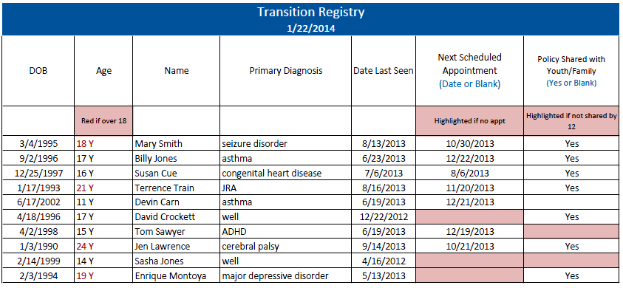
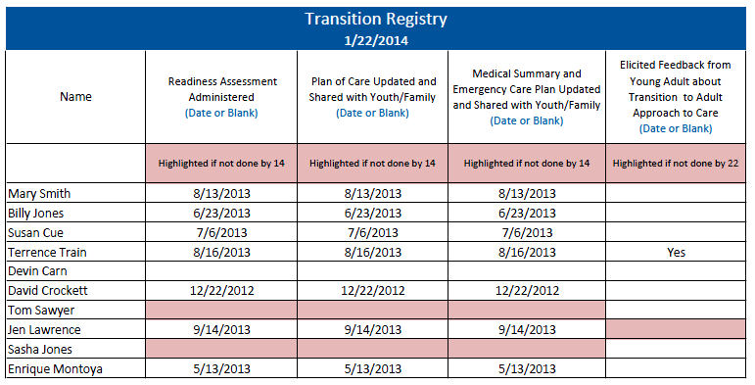

Please fill out this form to help us see what you already know about your health, using health care and areas that you need to learn more about. If you need help completing this form, please let us know.
Date:
Name: Date of Birth:

Transition and Self-Care Importance and Confidence On a scale of 0 to 10, please circle the number that best describes how you feel right now.

How important is it to you to manage your own health care?
0 (not) | 1 | 2 | 3 | 4 | 5 | 6 | 7 | 8 | 9 | 10 (very)
How confident do you feel about your ability to manage your own health care?
0 (not) | 1 | 2 | 3 | 4 | 5 | 6 | 7 | 8 | 9 | 10 (very)

My Health Please check the box that applies to you right now. | Yes, I know this |  | I need to learn | Someone needs to do this… Who?
I know my medical needs. | ☐ |  | ☐ | ☐
I can explain my medical needs to others. | ☐ |  | ☐ | ☐
I know my symptoms including ones that I quickly need to see a doctor for. | ☐ |  | ☐ | ☐
I know what to do in case I have a medical emergency. | ☐ |  | ☐ | ☐
I know my own medicines, what they are for, and when I need to take them. | ☐ |  | ☐ | ☐
I know my allergies to medicines and the medicines I should not take. | ☐ |  | ☐ | ☐
I can explain to others how my customs and beliefs affect my health care decisions and medical treatment. | ☐ |  | ☐ | ☐
Using Health Care
I know or I can find my doctor’s phone number. |  | ☐ | ☐ | ☐
I make my own doctor appointments. |  | ☐ | ☐ | ☐
Before a visit, I think about questions to ask. |  | ☐ | ☐ | ☐
I have a way to get to my doctor’s office. |  | ☐ | ☐ | ☐
I know I need to show up 15 minutes before the visit to check in. |  | ☐ | ☐ | ☐
I know where to go to get medical care when the doctor’s office is closed. |  | ☐ | ☐ | ☐
I have a file at home for my medical information. |  | ☐ | ☐ | ☐
I know how to fill out medical forms. |  | ☐ | ☐ | ☐
I know how to get referrals to other providers. |  | ☐ | ☐ | ☐
I know where my pharmacy is and how to refill my medicines. |  | ☐ | ☐ | ☐
I know where to get blood work or x-rays done if my doctor orders them. |  | ☐ | ☐ | ☐
I carry important health information with me every day (e.g. insurance card, allergies, medications, emergency contact information, medical summary). |  | ☐ | ☐ | ☐
I understand how health care privacy changes at age 18 when legally an adult. |  | ☐ | ☐ | ☐
I have a plan so I can keep my health insurance after 18 or older. |  | ☐ | ☐ | ☐
My family and I have discussed my ability to make my own health care decisions at age 18. |  | ☐ | ☐ | ☐

Please fill out this form to help us see what your child already knows about his or her health and the areas that you think he/she needs to learn more about. After you complete the form, compare your answers with the form your child has complete. Your answers may be different. We will help you work on some steps to increase your child’s health care skills.
Date:
Name: Date of Birth:
Transition and Self-Care Importance and Confidence On a scale of 0 to 10, please circle the number that best describes how you feel right now.

How important is it for your child to manage his or her own health care?
0 (not) | 1 | 2 | 3 | 4 | 5 | 6 | 7 | 8 | 9 | 10 (very)
How confident do you feel about your child’s ability to manage his or her own health care?
0 (not) | 1 | 2 | 3 | 4 | 5 | 6 | 7 | 8 | 9 | 10 (very)

My Health Please check the box that applies to you right now. | Yes, he/she knows this | He/she needs to learn | Someone needs to do this… Who?
My child knows his/her medical needs. | ☐ | ☐ | ☐
My child can explain his/her medical needs to others. | ☐ | ☐ | ☐
My child knows his/her symptoms including ones that he/she quickly needs to see a doctor for. | ☐ | ☐ | ☐
My child knows what to do in case he/she has a medical emergency. | ☐ | ☐ | ☐
My child knows his/her own medicines, what they are for, and when he/she needs to take them. | ☐ | ☐ | ☐
My child knows his/her allergies to medicines and medicines he/she should not take. | ☐ | ☐ | ☐
My child can explain to others how his/her customs and beliefs affect health care decisions and medical treatment. | ☐ | ☐ | ☐
Using Health Care
My child knows or can find his/her doctor’s phone number. | ☐ | ☐ | ☐
My child makes his/her own doctor appointments. | ☐ | ☐ | ☐
Before a visit, my child thinks about questions to ask. | ☐ | ☐ | ☐
My child has a way to get to his/her doctor’s office. | ☐ | ☐ | ☐
My child knows to show up 15 minutes before the visit to check in. | ☐ | ☐ | ☐
My child knows where to go to get medical care when the doctor’s office is closed. | ☐ | ☐ | ☐
My child has a file at home for his/her medical information. | ☐ | ☐ | ☐
My child has a copy of his/her current plan of care. | ☐ | ☐ | ☐
My child knows how to fill out medical forms. | ☐ | ☐ | ☐
My child knows how to get referrals to other providers. | ☐ | ☐ | ☐
My child knows where his/her pharmacy is and how to refill his/her medicines. | ☐ | ☐ | ☐
My child knows where to get blood work or x-rays if his/her doctor orders them. | ☐ | ☐ | ☐
My child carries important health information with him/her every day (e.g. insurance card, allergies, medications, emergency contact information, medical summary). | ☐ | ☐ | ☐
My child knows he/she can see a doctor alone as I wait in the waiting room. | ☐ | ☐ | ☐
My child understands how health care privacy changes at age 18. | ☐ | ☐ | ☐
My child has a plan to keep his/her health insurance after ages 18 or older. | ☐ | ☐ | ☐
My child and I have discussed his/her ability to make his/her own health care decisions at age 18. | ☐ | ☐ | ☐
My child and I have discussed a plan for supported decision-making, if needed. | ☐ | ☐ | ☐

Instructions: This sample plan of care is a written document developed jointly with the youth/young adult to establish priorities and a course of action that integrates health and personal goals. Motivational interviewing and strength-based counseling are key approaches in developing a collaborative process and shared decision-making. Information from the transition readiness assessment can be used to guide the development of health goals. The plan of care should be dynamic and updated regularly.
Name: |  |  |  |  | Date of Birth:
Primary Diagnosis: |  |  |  |  | Secondary Diagnosis:
What matters most to you as you become an adult? How can learning more about your health condition and how to use health care support your goals?

Prioritized Goals |  | Issues or Concerns |  |  |  | Actions |  | Person Responsible |  | Target Date | Date  Complete
Initial Date of Plan: | ________________ |  | Last Updated: | _____________________ |  |  | Patient Signature: |  | ___________________
Clinician Signature: | ________________ |  | Care Staff Contact: | ____________________ |  |  | Care Staff Phone: |  | ___________________

This document should be shared with and carried by the patient.
Date Completed: |  |  |  |  |  |  |  |  |  |  |  |  |  | Date Revised:
Form Completed By:
Contact Information
Name: |  |  |  |  |  |  |  |  |  |  |  |  |  | Nickname:
DOB: |  |  |  |  |  |  |  |  |  |  |  |  |  | Preferred Language:
Parent (Caregiver): |  |  |  |  |  |  |  |  |  |  |  |  |  | Relationship:
Address:
Cell #: Home #: |  |  |  |  |  |  |  |  |  |  |  |  |  |  | Best Time to Reach:
E-Mail: |  |  |  |  |  |  |  |  |  |  |  |  |  |  | Best Way to Reach: Text Phone Email
Health Insurance/Plan: |  |  |  |  |  |  |  |  |  |  |  |  |  |  | Group and ID #:
Emergency Care Plan
Emergency Contact: Relationship: Phone:
Preferred Emergency Care Location:
Common Emergent Presenting Problems |  |  |  |  |  |  |  | Suggested Tests |  |  |  |  |  |  |  | Treatment Considerations
Special Concerns for Disaster:
Allergies and Procedures to be Avoided
Allergies |  |  |  |  |  |  |  | Reactions
To be avoided |  |  |  |  |  |  |  | Why?
Medical Procedures:
Medications:
Diagnoses and Current Problems
Problem |  |  |  |  |  |  |  | Details and Recommendations
Primary Diagnosis

Secondary Diagnosis

Behavioral
Communication
Feed & Swallowing
Hearing/Vision
Learning
Orthopedic/Musculoskeletal
Physical Anomalies
Respiratory
Sensory
Stamina/Fatigue
Other
Medications
Medications |  | Dose |  | Frequency |  |  |  |  |  | Medications |  |  |  |  |  |  |  | Dose |  | Frequency
Health Care Providers
Provider |  |  | Primary and Specialty |  |  |  |  |  | Clinic or Hospital |  |  |  |  |  |  |  |  |  | Phone |  | Fax
Prior Surgeries, Procedures, and Hospitalizations
Date
Date
Date
Date
Date
Baseline
Baseline Vital Signs: Ht Wt RR HR BP
Baseline Neurological Status:
Most Recent Labs and Radiology
Test |  |  |  |  |  | Date |  |  |  |  |  |  | Result
EEG
EKG
X-Ray
C-Spine
MRI/CT
Other

Other

Equipment, Appliances, and Assistive Technology
Gastrostomy |  |  |  |  | Adaptive Seating |  |  |  |  |  |  |  |  |  |  |  | Wheelchair
Tracheostomy |  |  |  |  | Communication Device |  |  |  |  |  |  |  |  |  |  |  | Orthotics
Suctions |  |  |  |  | Monitors: |  |  |  |  |  |  |  |  |  |  |  | Crutches
Nebulizer |  |  |  |  | Apnea |  |  |  |  |  |  | O2 |  |  |  |  | Walker
 |  |  |  |  | Cardiac |  |  |  |  |  |  | Glucose
Other

School and Community Information
Agency/School |  |  |  |  |  |  | Contact Information
 |  |  |  |  |  |  | Contact Person: Phone:
 |  |  |  |  |  |  | Contact Person: Phone:
 |  |  |  |  |  |  | Contact Person: Phone:
Special information that the patient wants health care professionals to know

_________________________________________________________________________________
Patient Signature Print Name Phone Number Date

_________________________________________________________________________________
Parent/Caregiver Print Name Phone Number Date
__________________________________________________________________________________
Primary Care Provider Signature Print Name Phone Number Date
__________________________________________________________________________________
Care Coordinator Signature Print Name Phone Number Date
Please attach the immunization record to this form.

Reprinted with permission from the Spina Bifida Association
Reprinted with permission from the Spina Bifida Association
This is a survey about your experience changing to an adult approach to care. You may choose to answer this survey or not. Your responses to this survey are confidential.
- How often does your health care provider explain things in a way that is easy to understand?
Always
Usually
Sometimes
Never

- How often does your health care provider listen carefully to you?
Always
Usually
Sometimes
Never

- Does your health care provider respect how your customs or beliefs affect your care?
A lot
Some
A little
Not at all

- Did your health care provider discuss with you or have an office policy that explains changing to an adult approach to care?
Yes
No

- Do you talk with your health care provider without your parent or guardian in the room?
Yes
No

- Does your health care provider actively work with you to gain skills to manage your own health and health care (e.g., know your medications and their side effects, know what to do in an emergency)?*
A lot
Some
A little
Not at all

- Does your health care provider actively work with you to think about and plan for the future (e.g., take time to discuss future plans about education, work, relationships, and development of independent living skills)?*
A lot
Some
A little
Not at all

- How often do you schedule your own appointments with your health care provider?
Never
Sometimes
Usually
Always

- Did your health care provider explain legal changes in privacy, decision-making, and consent that take place at age 18?
Yes
No

- Does your health care provider actively work with you to create a written plan to meet your health goals and needs?*
Yes
No

- Does your health care provider update and share a medical summary with you?
Yes
No

- Do you know how you will be insured as you become an adult?*
Yes
No

- How could your health care provider have made changing to an adult approach to care better?
________________________________________________________________________________________________________________________________________________________________________________________________________________________________________________
*Adapted from the National Survey of Children’s Health

This is a survey about your experience changing to an adult approach to care. You may choose to answer this survey or not. Your responses to this survey are confidential.
- How often did your child’s health care provider explain things in a way that is easy to understand?
Always
Usually
Sometimes
Never

- How often did your child’s health care provider listen carefully to you?
Always
Usually
Sometimes
Never

- Does your child’s health care provider respect how your customs or beliefs affect your care?
A lot
Some
A little
Not at all

- Did your child’s health care provider discuss with you or have an office policy that explains changing to an adult approach to care?
Yes
No

- Did your child’s health care provider talk to your child without you in the room?
Yes
No

- Did your child’s health care provider actively work with your child to gain skills to manage his or her own health and health care (e.g., know his or her medications and their side effects, know what to do in an emergency)?*
A lot
Some
A little
Not at all

- Did your child’s health care provider actively work with your child to think about and plan for the future (e.g., take time to discuss future plans about education, work, relationships, and development of independent living skills)?*
A lot
Some
A little Not at all
- How often did your child schedule his or her own appointments with his or her health care provider?
Never
Sometimes
Usually
Always

- Did your child’s health care provider explain legal changes in privacy, decision-making, and consent that take place at age 18?
Yes
No

- Does your child’s health care provider actively work with him or her to create a written plan to meet his or her health goals and needs?*
Yes
No

- Did your child’s health care provider create and share a medical summary with your child?
Yes
No

- Do you know how your child will be insured as he or she becomes an adult?*
Yes
No

- How could your child’s health care provider have made changing to an adult approach to care better for your child?
________________________________________________________________________________________________________________________________________________________________________________________________________________________________________________________________________________________________________________________________________________
*Adapted from the National Survey of Children’s Health
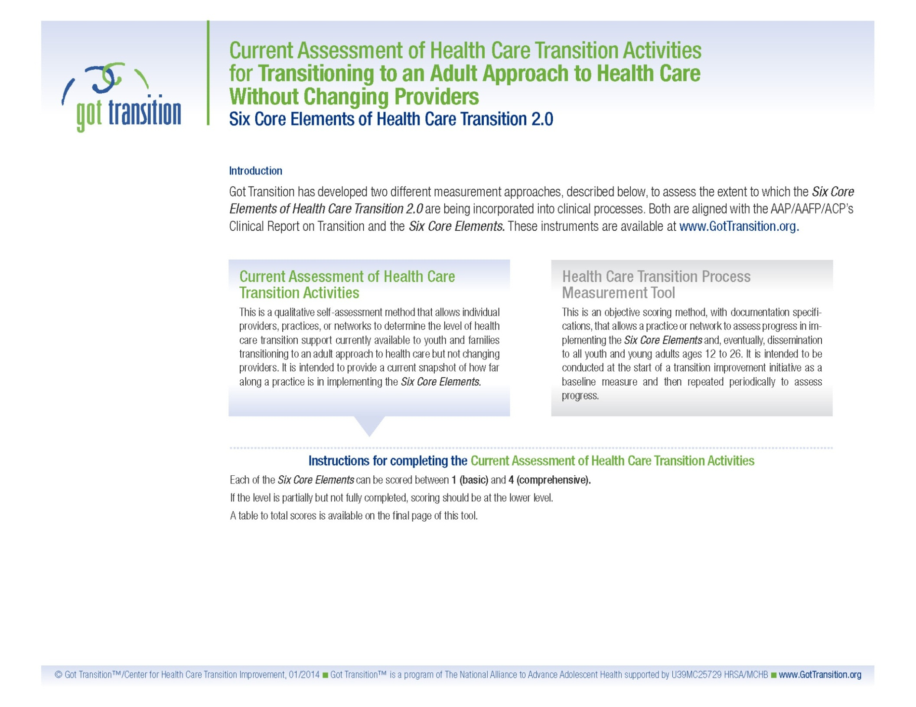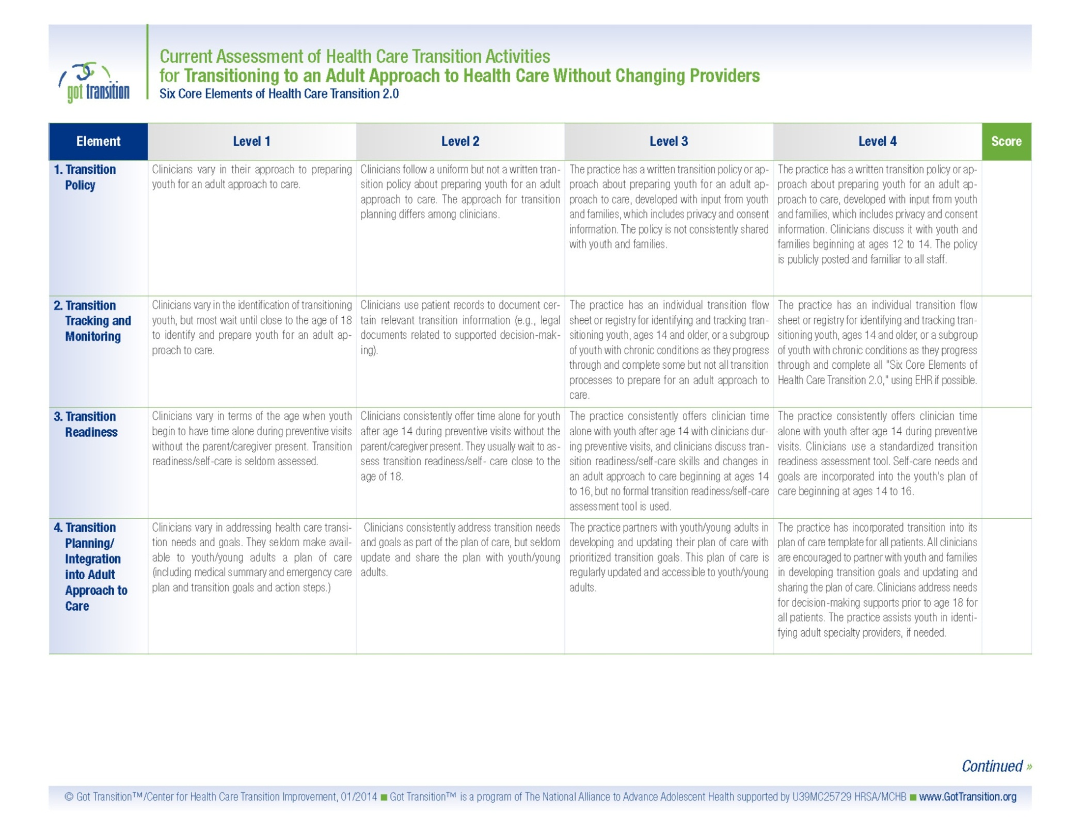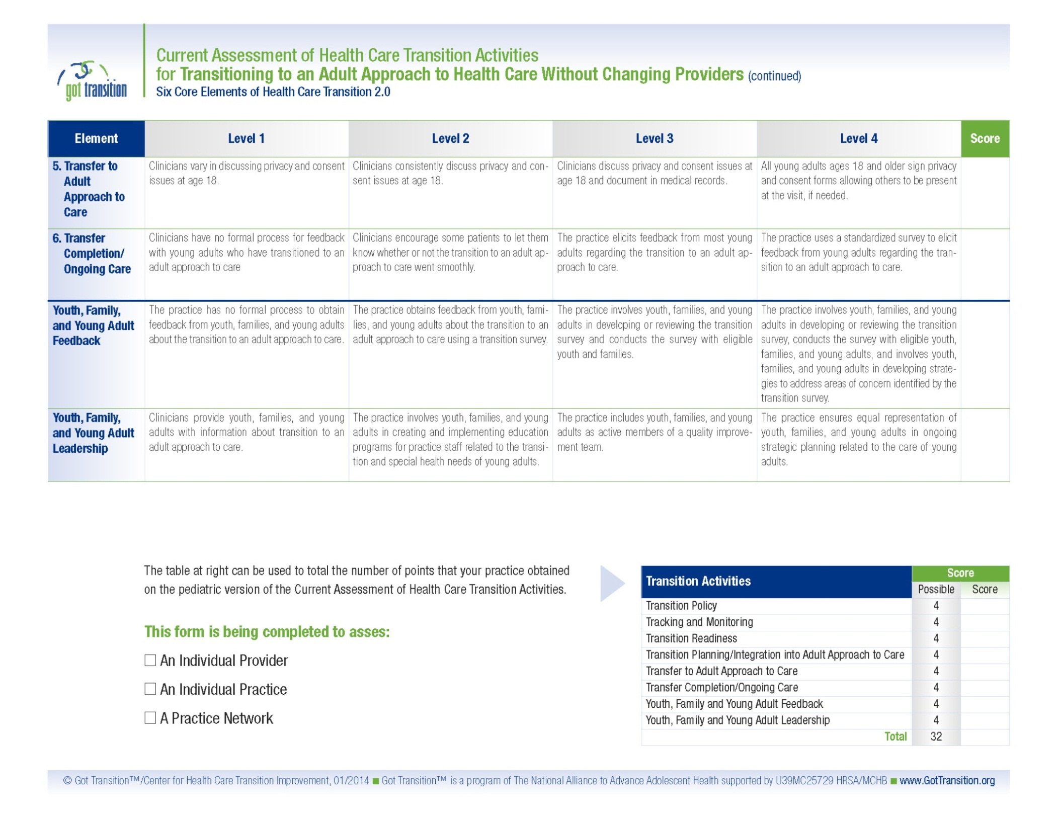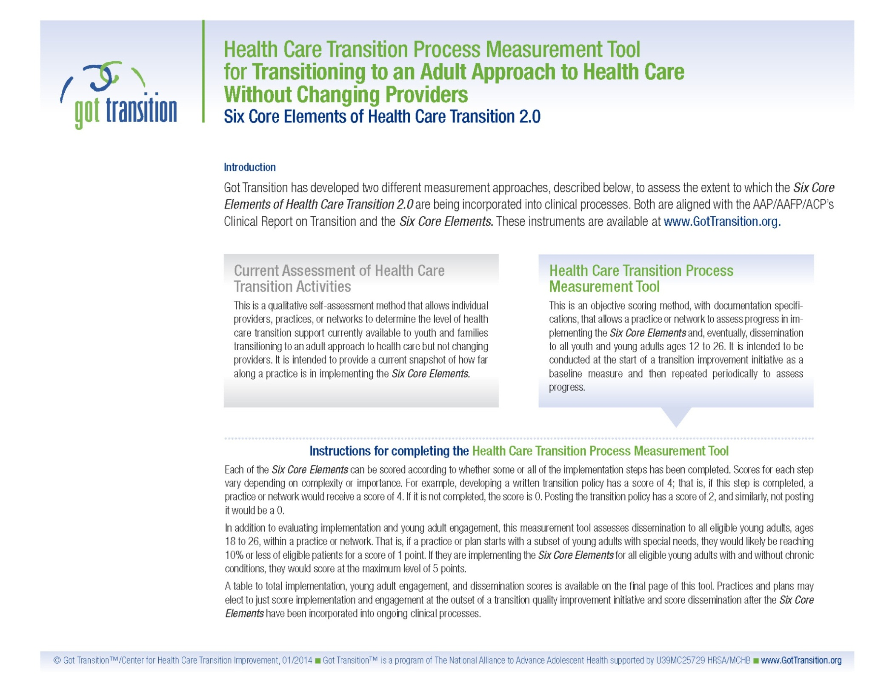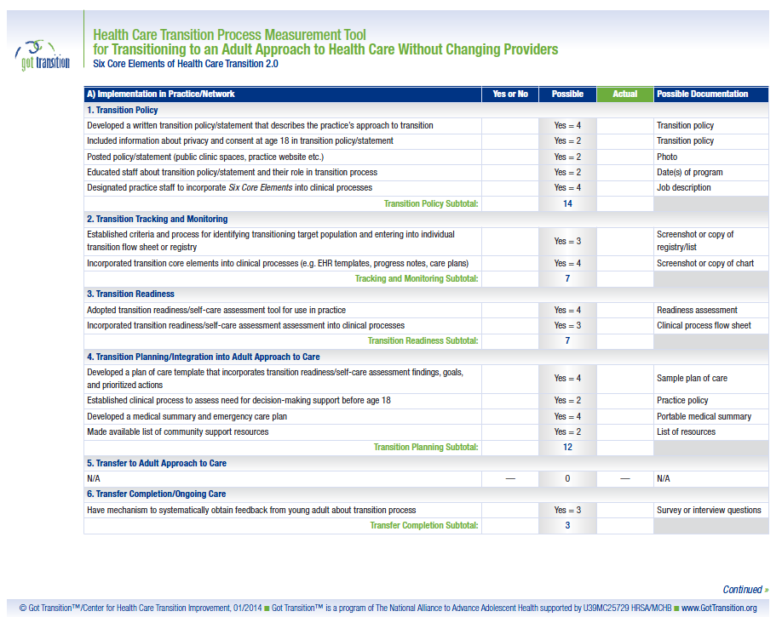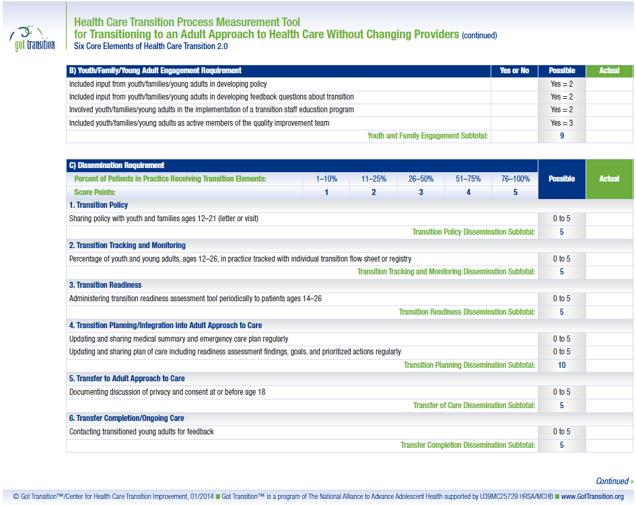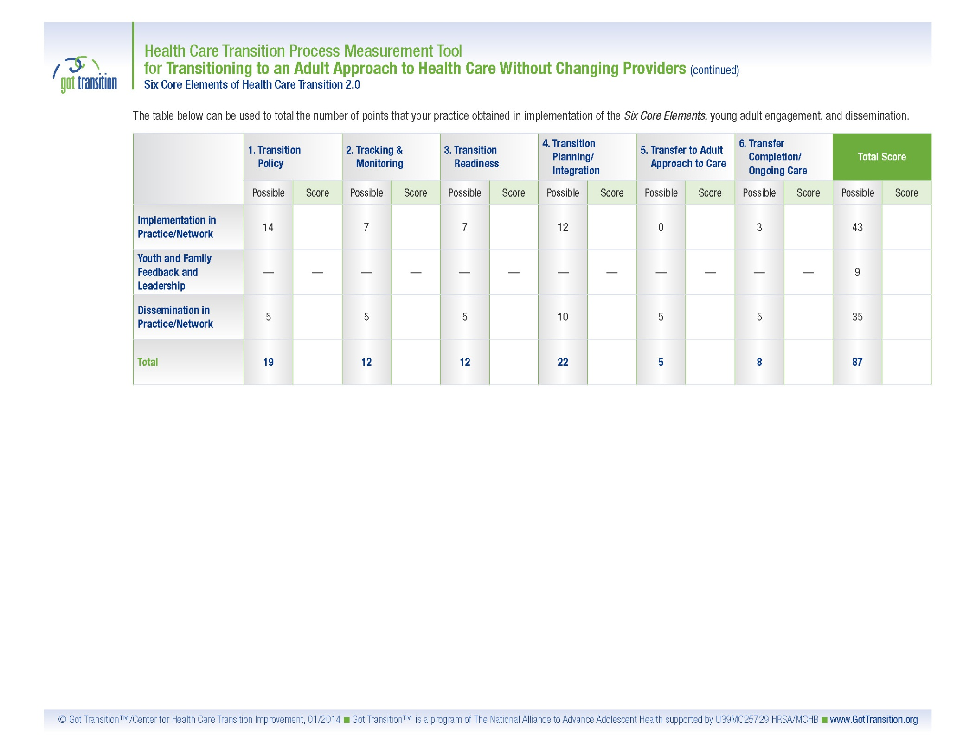

American Academy of Pediatrics, American Academy of Family Physicians, and American College of Physicians. Transitions Clinical Report Authoring Group. Supporting the health care transition from adolescence to adulthood in the medical home. Pediatrics. 2011: 128; 182.
White, PH, McManus MA, McAlister JW, Cooley WC. A primary care quality improvement approach to health care transition. Pediatric Annals. 2012: 41; 5.
To access all three transition packages, see www.GotTransition.org.
Additional information can be found at: http://www.hhs.gov/ocr/civilrights/resources/specialtopics/lep/index.html and at: http://www.health.gov/communication/literacy/
Additional information can be found at www.thinkculturalhealth.hhs.gov
Taylor MJ, McNicholas C, Nicolay C, Darzi A, Bell D, Reed JE. Systematic review of the application of the plan-do-study-act method to improve quality in healthcare. BMJ Quality and Safety. 2013:0;1.

