Table of Contents
Preamble | 1
Six Core Elements of Health Care Transition 2.0: Side-by-Side Version | 2
Six Core Elements of Health Care Transition 2.0: Integrating Young Adults into Adult Health Care | 4
Introduction to Each of the Six Core Elements | 5
Core Element Samples
- Young Adult Transition and Care Policy
- Sample Young Adult Transition and Care Policy | 7
- Young Adult Tracking and Monitoring
- Sample Individual Transition Flow Sheet | 8
- Sample Transition Registry | 9
- Transition Readiness/Orientation to Adult Practice
- Sample Welcome and Orientation of New Young Adults | 10
- Transition Planning/Integration into Adult Practice
- Sample Plan of Care | 11
- Sample Medical Summary and Emergency Care Plan | 12
- Sample Condition Fact Sheet | 15
- Transfer of Care/Initial Visit
- Sample Self-Care Assessment for Young Adults | 17
- Transfer Completion/Ongoing Care
- Sample Health Care Transition Feedback Survey for Young Adults | 18
Measurement Approaches
- Current Assessment of Health Care Transition Activities | 19
- Health Care Transition Process Measurement Tool | 22
Six Core Elements of Health Care Transition 2.0
Integrating Young Adults into Adult Health Care
for use by Internal Medicine, Family Medicine, and Med-Peds Providers

Got Transition is pleased to share this updated package of the Six Core Elements of Health Care Transition for use by internal medicine, family medicine, and med-peds providers to benefit all young adults as they transition from pediatric to adult-centered health care. Consistent with the AAP/AAFP/ACP Clinical Report on Health Care Transition, transition consists of joint planning with young adults to foster development of self-care skills and active participation in decision-making. It also consists ensuring a smooth transfer to adult-centered care with current medical information.
Recognizing and responding to the diversity among young adults and their families is essential to the transition process. This diversity may include but is not limited to differences in culture, race, ethnicity, languages spoken, intellectual abilities, gender, sexual orientation, and age. Since implementation of the Six Core Elements depends so much on patient and provider communication, health plans and practices should use appropriate oral and written communications, including interpretation and translation services and health literacy supports as needed. In addition, engaging young adult and parents/caregivers from various cultural backgrounds in the development and evaluation of a transition quality improvement process is important.
The Six Core Elements of Health Care Transition 2.0 define the basic components of health care transition support. The linked sample tools in this package provide tested means for integrating young adults into adult health care. Corresponding packages are available for 1) transitioning youth to adult health care providers and 2) transitioning to an adult approach to care without changing providers. Originally developed in 2009, this updated version incorporates the results of recent transition learning collaborative experiences in several states, an examination of transition innovations in the United States and abroad, and reviews by over 50 pediatric and adult health care professionals and youth and family experts.
To implement the Six Core Elements, a quality improvement approach is recommended. Plan-do-study-act (PDSA) cycles provide a useful way to incrementally adopt the Six Core Elements as a standard part of care for young adult and their families. The process begins with the creation of a collaborative pediatric and adult team that could include physicians, nurse practitioners, physician assistants, nurses, social workers, care coordinators, medical assistants, administrative staff, IT staff, and young adult/young adults and families. Leadership support from the practice, plan, or academic department is critical as well. Oftentimes, practices decide to begin with a subset of young adult in order to pilot the pediatric and adult delivery system changes needed for transition. Sample tools that can be customized for use in primary and specialty care are available in this package and on www.GotTransition.org.
Got Transition has developed two different measurement approaches, described below, to assess the extent to which the Six Core Elements of Health Care Transition 2.0 are being incorporated into clinical processes. Both are aligned with the AAP/AAFP/ACP’s Clinical Report on Transition and the Six Core Elements.
- Current Assessment of Health Care Transition Activities. This is a qualitative self-assessment method that allows individual providers, practices, or networks to determine the level of health care transition support currently available to young adults transitioning from pediatric to adult health care. It is intended to provide a current snapshot of how far along a practice is in implementing the Six Core Elements.
- Health Care Transition Process Measurement Tool. This is an objective scoring method, with documentation specifications, that allows a practice or network to assess progress in implementing the Six Core Elements and, eventually, dissemination to all young adults ages 18 to 26. It is intended to be conducted at the start of a transition improvement initiative as a baseline measure and then repeated periodically to assess progress.
This tool package contains the Six Core Elements of Health Care Transition 2.0 side-by-side version followed by the Six Core Elements version for providers assisting young adult transitioning to a new adult provider and sample tools.
Got Transition welcomes your comments and feedback on the updated Six Core Elements of Health Care Transition 2.0. Please send your feedback to info@GotTransition.org. Thank you for your interest in the successful health care transitions of young adults from pediatric to adult-centered care.

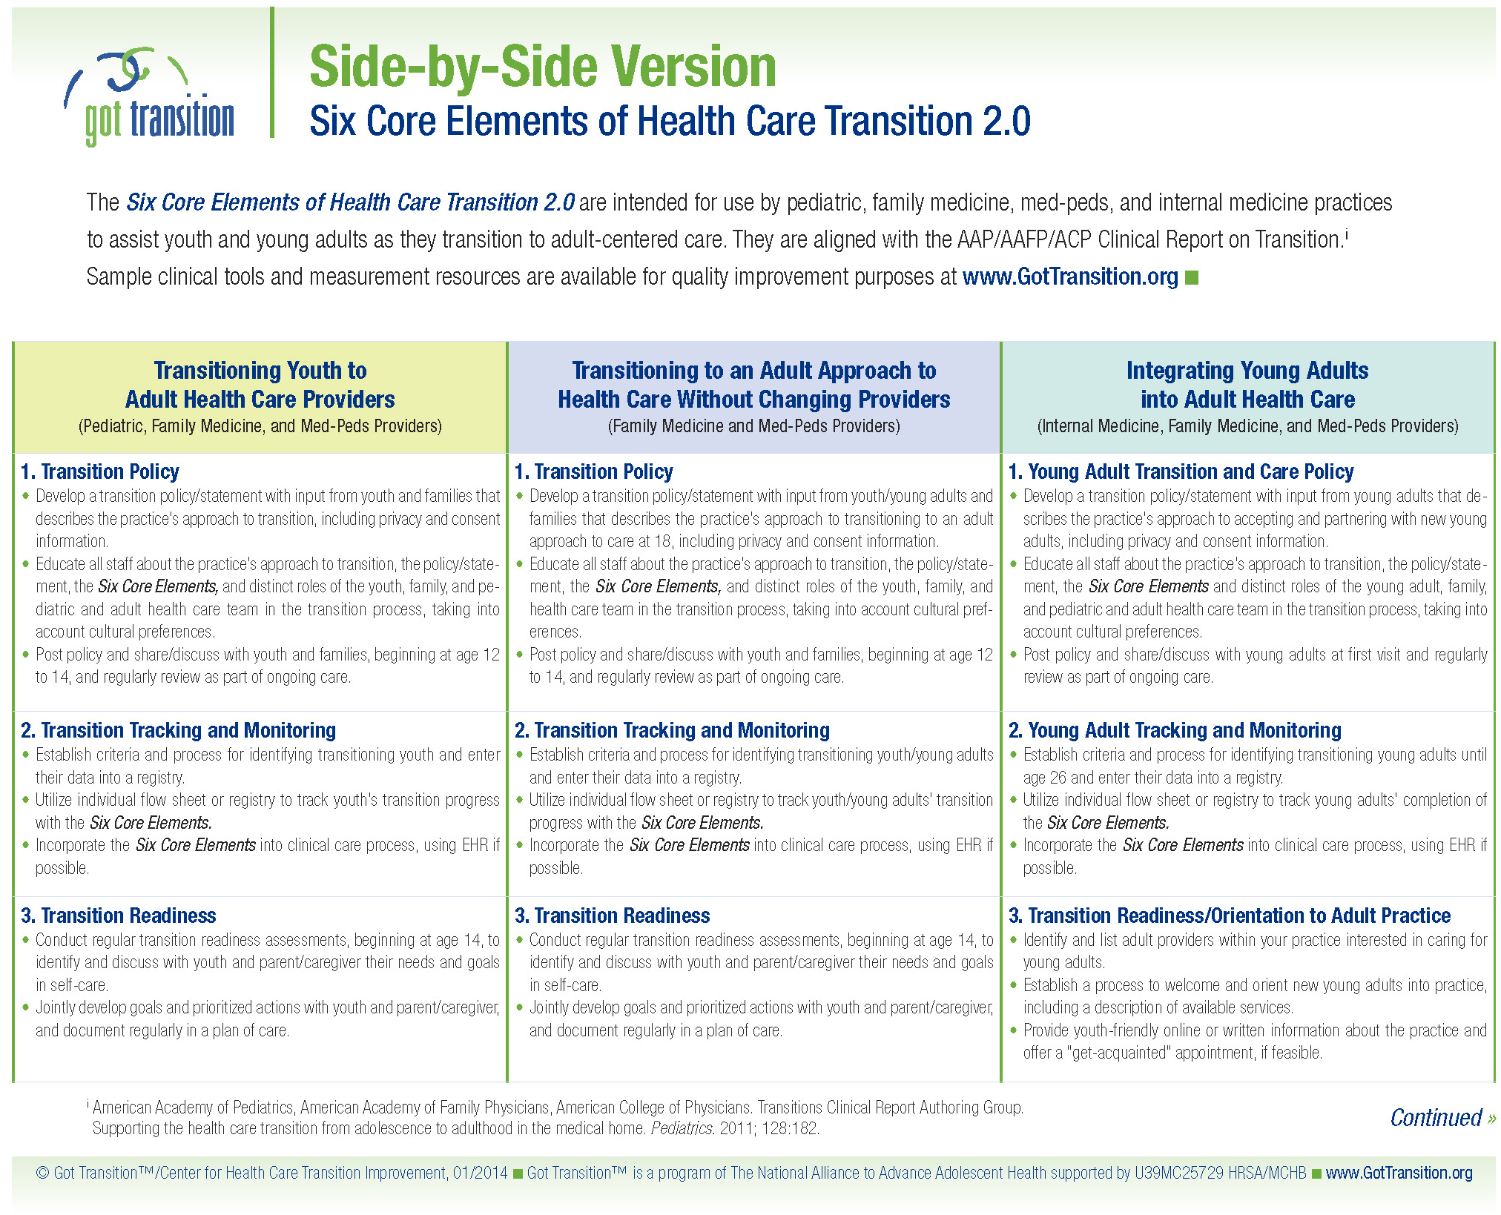

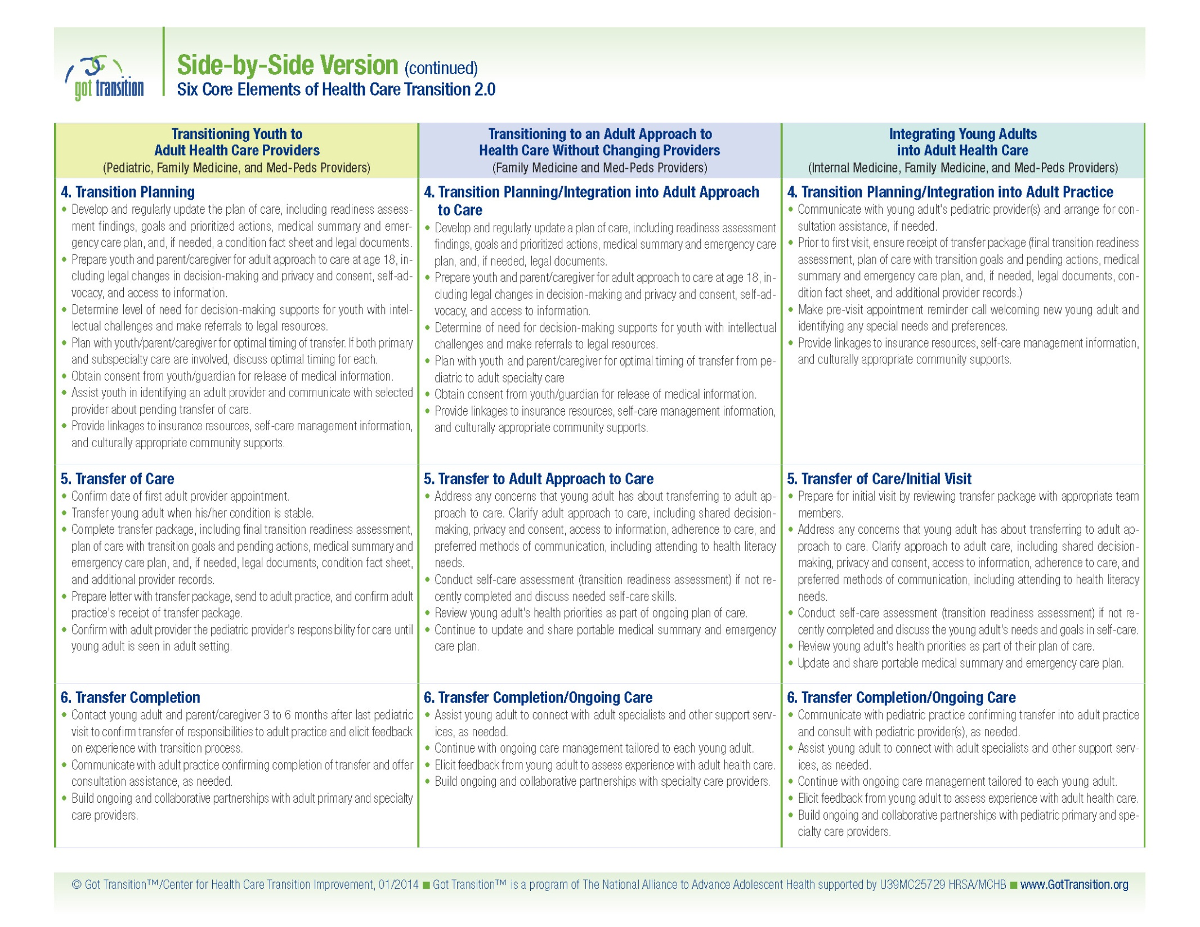

1. Young Adult Transition and Care Policy
- Develop a transition policy/statement with input from young adults that describes the practice’s approach to accepting and partnering with new young adults, including privacy and consent information.
- Educate all staff about the practice’s approach to transition, the policy/statement, the Six Core Elements, and distinct roles of the young adult, family, and pediatric and adult health care team in the transition process, taking into account cultural preferences.
- Post policy and share/discuss with young adults at first visit and regularly review as part of ongoing care.
2. Young Adult Tracking and Monitoring
- Establish criteria and process for identifying transitioning young adults until age 26 and enter their data into a registry.
- Utilize individual flow sheet or registry to track young adults’ completion of Six Core Elements.
- Incorporate Six Core Elements into clinical care process, using EHR if possible.
3. Transition Readiness/Orientation to Adult Practice
- Identify and list adult providers within your practice interested in caring for young adults.
- Establish a process to welcome and orient new young adults into practice, including a description of available services.
- Provide young adult-friendly online or written information about the practice and offer a “get-acquainted” appointment, if feasible.
4. Transition Planning/Integration into Adult Practice
- Communicate with young adult’s pediatric provider(s) and arrange for consultation assistance, if needed.
- Prior to first visit, ensure receipt of transfer package (final transition readiness assessment, plan of care with transition goals and pending actions, medical summary and emergency care plan, and, if needed, legal documents, condition fact sheet, and additional provider records.)
- Make pre-visit appointment reminder call welcoming new young adult and identifying any special needs and preferences.
- Provide linkages to insurance resources, self-care management information, and culturally appropriate community supports.
5. Transfer of Care/Initial Visit
- Prepare for initial visit by reviewing transfer package with appropriate team members.
- Address any concerns that young adult has about transferring to adult approach to care. Clarify adult approach to care, including shared decision-making, privacy and consent, access to information, adherence to care, and preferred methods of communication, including attending to health literacy needs.
- Conduct self-care assessment (transition readiness assessment) if not recently completed and discuss their needs and goals in self-care.
- Review young adult’s health priorities as part of their plan of care.
- Update and share portable medical summary and emergency care plan.
6. Transfer Completion/Ongoing Care
- Communicate with pediatric practice confirming transfer into adult practice and consult with pediatric provider(s), as needed.
- Assist young adult to connect with adult specialists and other support services, as needed.
- Continue with ongoing care management tailored to each young adult.
- Elicit feedback from young adult to assess experience with adult health care.
- Build ongoing and collaborative partnerships with pediatric primary and specialty care providers.

- Young Adult Transition and Care Policy
Creating a written practice policy on transition is the first element in these health care transition quality recommendations. Developed by your practice or health system, with input from young adults, the policy provides consensus among the practice staff, mutual understanding of the process involved, and a structure for evaluation. The policy should include the practice’s approach to accepting and partnering with young adults. It should also explain the legal changes that take place in privacy and consent at age 18. The policy should be shared with young adults at their first visit and be publicly posted.
- Young Adult Tracking and Monitoring
Establishing a mechanism to track progress of each young adult as they receive the Six Core Elements is the second element in these health care transition quality recommendations. An individual flow sheet within the chart can be used to track individual patient progress with the Six Core Elements. Information from an individual flow sheet can be used to populate a registry and help to monitor the transition progress within a larger population. Practices may elect to start monitoring transition progress with a subset of young adults with chronic conditions. The long-term goal is to track health care transition progress among all young adults ages 18-26, with and without chronic conditions.
- Transition Readiness/Orientation to the Adult Practice
Orienting young adults to the adult practice is the third element in these health care transition quality recommendations. To begin with, the practice should identify those providers interested in taking on new young adult patients. The names of these providers should be shared with front desk staff and with partnering pediatric practices. Because young adults are relatively new health care consumers, an orientation to the adult practice is important. Establishing a process and designating staff members to welcome young adults will ensure that orientation is an integral component of the clinic work flow. The practice should provide young adult-friendly welcome materials that describe confidentiality, services offered, and the logistics of obtaining care. Offering get-acquainted appointments, if feasible can be a useful option for some prospective young adult patients.
- Transition Planning/Integration into the Adult Practice
Planning with the pediatric provider for the transition of young adults is the fourth element in these health care transition recommendations. Adult practices should ensure receipt of the young adult’s transfer package from the pediatric practice. A transfer package should include a final transition readiness assessment, plan of care, medical summary and emergency care plan, and, if needed, legal documents, a condition fact sheet and subspecialist records. The adult practice must communicate with the pediatric practice about their residual responsibility for care until the first visit to the adult provider is completed. Until the young adult has gone to the first appointment and established care in the new medical home, the pediatric provider has some residual responsibility for care (e.g. medication refills or acute care visits). In the case of young adultswith complicated health or psychosocial needs, direct provider communication is encouraged. Adult providers can also establish a plan for further consultation with the pediatric provider should the need arise. After all records are obtained and the pediatric practice is contacted, the adult practice should make a pre-visit call to welcome the patient, remind them of their upcoming appointment, and identify any special needs or preferences. Community resource information on insurance, self-care management, and culturally appropriate supports can be helpful to young adults.

- Transfer of Care/Initial Visit
Welcoming and orienting the new young adult into the adult practice is the fifth element in these health care transition quality recommendations. Following review of the transfer package, the initial appointment should address any concerns that the young adult may have in transferring to a new adult provider and distinctions between pediatric and adult care. Specifically, it is important to discuss confidentiality, access to information, and shared decision-making and to elicit how to best communicate with the young adult. Over the next few visits, the provider should work with the young adult to assess and strengthen self-care skills. Use of a standardized self-care assessment tool can be helpful in engaging young adults in their care and assisting them in navigating the adult health care system, including health insurance. Providers can use the results of this assessment to develop a plan of care with the young adults. Finally, updating and sharing a medical summary and emergency care plan helps to further engage young adults in their own care.
- Transfer Completion/Ongoing Care
Confirming transfer completion, coordinating transfer to adult specialists, and assessing young adult’s experience with transition support are all part of the sixth element in these health care transition quality recommendations. Confirming with the pediatric practice that the adult provider has taken on responsibility for the young adult’s health care is necessary. Since many young adults may transfer to an adult primary care provider first, helping them to select new adult specialist providers may be necessary. To evaluate the success of the transition process and the young adult’s experience with care, having a mechanism to obtain and incorporate the feedback six months after the first visit will improve the practice’s approach to integrating young adults into the practice.

[Adult Practice Name] welcomes young adults, including those with special health care needs, to our practice. We aim to provide high quality, comprehensive, and confidential health care to meet young adults’ unique needs.
Our practice places the young adult, ages 18 and older, in the center of his/her own health care, with the health care provider as a partner in supporting your health goals. This means that adult providers do not discuss any aspects of your care with anyone else unless you specifically ask that we do. We understand that some young adults involve family and close friends in their health care decisions and would like their provider to share information with those close to them. To allow others to be involved in your health care decisions requires that a signed consent form be completed, which is available at the clinic. For young adults unable to provide consent, we will need legal documentation about decision-making arrangements.
We ask that new patients transferring to our practice obtain from their previous provider(s) a medical summary or medical record and send it to us before the first appointment. We make every effort to coordinate the transfer of care with previous providers, including communicating with pediatric providers and assisting with transfer of specialty care, as needed. Having your medical information in advance helps to ensure greater continuity of care and a better experience for you.
Your health is important to us, and we look forward to having you as a new patient. If you have any questions or concerns, please feel free to contact us.

Patient Name: ______________ Date of Birth: ___________

Primary Diagnosis: ______________ Transition Complexity: ______________
Low, moderate or high
Welcome and Orientation
-Contacted young adult before the first visit to welcome and answer questions _________
Date
-Transfer package received from pediatric provider _________
Date
- Transfer letter
- Final transition readiness assessment
- Plan of care, including transition goals and pending actions
- Updated medical summary and emergency care plan
- Guardianship or health proxy documents, if needed
- Condition fact sheet, if needed
- Additional provider records, if needed
-Orientation material shared with young adult _________
Date
-Practice policy on transition discussed/shared with young adult _________
Date
Adult Model of Care
-Clarified adult approach to care, including shared decision-making, privacy and consent, access to information, adherence to care, and preferred methods of communication _________
Date
-If needed and not previously addressed, discussed legal options for supported decision-making _______
Date
Self-Care Assessment
-Conducted self-care assessment _________ _________ _________
Date Date Date
-Included self-care goals and prioritized actions in plan of care _________ _________ _________
Date Date Date
Medical Summary and Emergency Care Plan
-Updated and shared medical summary and emergency care plan _________ _________ _________
Date Date Date
Transfer Completion
-Communicated with pediatric provider confirming transfer or care and arranging for consultation, if needed _________
Date
-Elicited feedback from young adult about transition and experience with care _________
Date

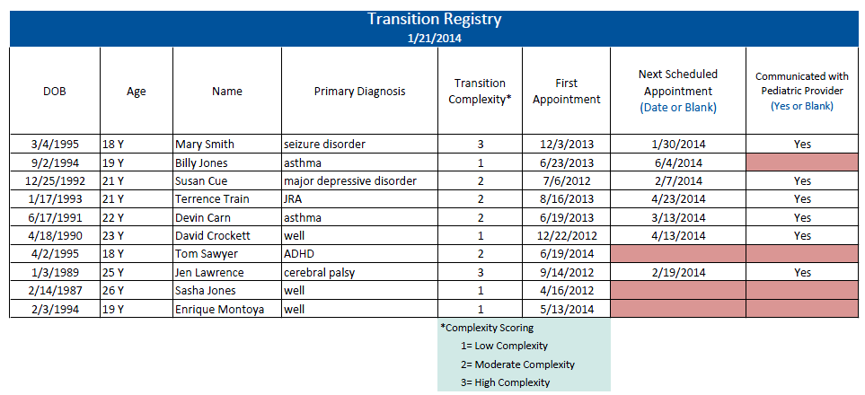

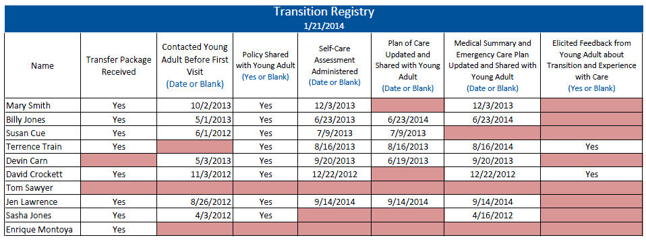

[Adult Practice Name] is pleased to welcome you into our practice. Our practice places young adults in the center of their own health care. This means that our providers do not discuss your care with anyone else unless you ask that we do. We understand that some young adults involve family and close friends in their health care decisions. To allow others to be involved in your health care decisions you will need to complete a signed consent. These forms are available at the clinic. For young adults unable to provide consent, we will need legal documentation about decision-making arrangements.
At our practice, you have the right to:
- Be treated in a caring way
- Make your own decisions
- Talk to your health care provider alone
- Have things explained in a way that you understand
- Have access to your medical information
In turn, you are responsible for:
- Keeping appointments and cancelling appointments in advance
- Telling us about your current symptoms and health history to help us treat you
- Following treatment plans that you develop with your health provider
- Asking questions about your care
- Knowing what your insurance covers
Below is a list of frequently asked questions and answers about our practice. If you have a question that is not listed below, feel free to ask any of our staff. We look forward to having you in our practice.
Q: What services does the practice provide (including preventive, acute and chronic illness care, and, if offered, sexual health, mental/behavioral health, wellness programs, and other specialty care)?
A:
Q: Are services confidential?
A:
Q: Where is the office located (including map and nearest public transportation)?
A:
Q: What providers are available to care for young adults?
A:
Q: What are the office hours (including walk-in options, if available)?
A:
Q: Are there after-hours call-in options?
A:
Q: How do I schedule, reschedule, or cancel an appointment?
A:
Q: What insurance is accepted?
A:
Q: How much do visits cost?
A:
Q: What should I bring for my first appointment?
A:
Q: What resources are available to assist me to learn about wellness and self-care (e.g., nutrition and fitness classes, support groups, special apps or websites, local community resources)?
A:

Instructions: This sample plan of care is a written document developed jointly with the young adult to establish priorities and a course of action that integrates health and personal goals. Motivational interviewing and strength-based counseling are key approaches in developing a collaborative process and shared decision-making. Information from the self-care assessment can be used to guide the development of health goals. The plan of care should be dynamic and updated regularly.
Name: |  |  |  |  | Date of Birth:
Primary Diagnosis: |  |  |  |  | Secondary Diagnosis:
What matters most to you as an adult? How can learning more about your health condition and how to use health care support your goals?

Prioritized Goals |  | Issues or Concerns |  |  |  | Actions |  | Person Responsible |  | Target Date | Date  Complete
Initial Date of Plan: | ________________ |  | Last Updated: | _____________________ |  |  | Young Adult Signature: |  | ___________________
Clinician Signature: | ________________ |  | Care Staff Contact: | ____________________ |  |  | Care Staff Phone: |  | ___________________

This document should be shared with and carried by the young adult.
Date Completed: |  |  |  |  |  |  |  |  |  |  |  |  |  | Date Revised:
Form completed by:
Contact Information
Name: |  |  |  |  |  |  |  |  |  |  |  |  |  | Nickname:
DOB: |  |  |  |  |  |  |  |  |  |  |  |  |  | Preferred Language:
Address:
Cell #: Home #: |  |  |  |  |  |  |  |  |  |  |  |  |  |  | Best Time to Reach:
E-Mail: |  |  |  |  |  |  |  |  |  |  |  |  |  |  | Best Way to Reach: Text Phone Email
Health Insurance/Plan: |  |  |  |  |  |  |  |  |  |  |  |  |  |  | Group and ID #:
Emergency Care Plan
Emergency Contact: Relationship: Phone:
Preferred Emergency Care Location:
Common Emergent Presenting Problems |  |  |  |  |  |  |  | Suggested Tests |  |  |  |  |  |  |  | Treatment Considerations
Special Concerns for Disaster:
Allergies and Procedures to be Avoided
Allergies |  |  |  |  |  |  |  | Reactions
To be avoided |  |  |  |  |  |  |  | Why?
Medical Procedures:
Medications:
Diagnoses and Current Problems
Problem |  |  |  |  |  |  |  | Details and Recommendations
Primary Diagnosis

Secondary Diagnosis

Behavioral
Communication
Feed & Swallowing
Hearing/Vision
Learning
Orthopedic/Musculoskeletal
Physical Anomalies
Respiratory
Sensory
Stamina/Fatigue
Other

Medications
Medications |  | Dose |  | Frequency |  |  |  |  |  | Medications |  |  |  |  |  |  |  | Dose |  | Frequency
Health Care Providers
Provider |  |  | Primary and Specialty |  |  |  |  |  | Clinic or Hospital |  |  |  |  |  |  |  |  |  | Phone |  | Fax
Prior Surgeries, Procedures, and Hospitalizations
Date
Date
Date
Date
Date
Baseline
Baseline Vital Signs: Ht Wt RR HR BP
Baseline Neurological Status:
Most Recent Labs and Radiology
Test |  |  |  |  |  | Date |  |  |  |  |  |  | Result
EEG
EKG
X-Ray
C-Spine
MRI/CT
Other

Other

Equipment, Appliances, and Assistive Technology
Gastrostomy |  |  |  |  | Adaptive Seating |  |  |  |  |  |  |  |  |  |  |  | Wheelchair
Tracheostomy |  |  |  |  | Communication Device |  |  |  |  |  |  |  |  |  |  |  | Orthotics
Suctions |  |  |  |  | Monitors: |  |  |  |  |  |  |  |  |  |  |  | Crutches
Nebulizer |  |  |  |  | Apnea |  |  |  |  |  |  | O2 |  |  |  |  | Walker
 |  |  |  |  | Cardiac |  |  |  |  |  |  | Glucose
Other
School, Work and Community Information
Agency/School |  |  |  |  |  |  | Contact Information
 |  |  |  |  |  |  | Contact Person: Phone:
 |  |  |  |  |  |  | Contact Person: Phone:
 |  |  |  |  |  |  | Contact Person: Phone:
Special information that the patient wants health care professionals to know

_________________________________________________________________________________
Patient/Guardian Signature Print Name Phone Number Date

__________________________________________________________________________________
Primary Care Provider Signature Print Name Phone Number Date
__________________________________________________________________________________
Care Coordinator Signature Print Name Phone Number Date
Please attach the immunization record to this form.

Reprinted with permission from the Spina Bifida Association
Reprinted with permission from the Spina Bifida Association
Please fill out this form to help us see what you already know about your health, using health care and areas that you need to learn more about. If you need help completing this form, please let us know.
Date:
Name: Date of Birth:

Transition and Self-Care Importance and Confidence On a scale of 0 to 10, please circle the number that best describes how you feel right now.

How important is it to you to manage your own health care?
0 (not) | 1 | 2 | 3 | 4 | 5 | 6 | 7 | 8 | 9 | 10 (very)
How confident do you feel about your ability to manage your own health care?
0 (not) | 1 | 2 | 3 | 4 | 5 | 6 | 7 | 8 | 9 | 10 (very)

My Health Please check the box that applies to you right now. | Yes, I know this |  | I need to learn | Someone needs to do this… Who?
I know my medical needs. | ☐ |  | ☐ | ☐
I can explain my medical needs to others. | ☐ |  | ☐ | ☐
I know my symptoms including ones that I quickly need to see a doctor for. | ☐ |  | ☐ | ☐
I know what to do in case I have a medical emergency. | ☐ |  | ☐ | ☐
I know my own medicines, what they are for, and when I need to take them. | ☐ |  | ☐ | ☐
I know my allergies to medicines and the medicines I should not take. | ☐ |  | ☐ | ☐
I can explain to others how my customs and beliefs affect my health care decisions and medical treatment. | ☐ |  | ☐ | ☐
Using Health Care
I know or I can find my doctor’s phone number. |  | ☐ | ☐ | ☐
I make my own doctor appointments. |  | ☐ | ☐ | ☐
Before a visit, I think about questions to ask. |  | ☐ | ☐ | ☐
I have a way to get to my doctor’s office. |  | ☐ | ☐ | ☐
I know I need to show up 15 minutes before the visit to check in. |  | ☐ | ☐ | ☐
I know where to go to get medical care when the doctor’s office is closed. |  | ☐ | ☐ | ☐
I have a file at home for my medical information. |  | ☐ | ☐ | ☐
I know how to fill out medical forms. |  | ☐ | ☐ | ☐
I know how to get referrals to other providers. |  | ☐ | ☐ | ☐
I know where my pharmacy is and how to refill my medicines. |  | ☐ | ☐ | ☐
I know where to get blood work or x-rays done if my doctor orders them. |  | ☐ | ☐ | ☐
I carry important health information with me every day (e.g. insurance card, allergies, medications, emergency contact information, medical summary). |  | ☐ | ☐ | ☐
I understand how health care privacy changes at age 18 when legally an adult. |  | ☐ | ☐ | ☐
I have a plan so I can keep my health insurance after 18 or older. |  | ☐ | ☐ | ☐

This is a survey about your experience with your new adult health care provider. You may choose to answer this survey or not. Your responses to this survey are confidential.
- Does your adult health care provider explain things in a way that is easy to understand?
Yes
No

- Does your adult health care provider listen carefully to you?
Yes
No

- Does your adult health care provider respect how your customs or beliefs affect your care?
Yes
No
Not applicable

- Did your adult health care provider discuss with you or have an office policy that explained their approach to accepting and partnering with young adult patients?
Yes
No

- Did your adult provider/practice provide written or online information describing their hours and services?
Yes
No

- Does your adult health care provider actively work with you to improve skills to manage your own health and health care (e.g., know your medications and their side effects, know what to do in an emergency)?*
A lot
Some
A little
Not at all

- Does your adult health care provider actively work with you to plan for the future (e.g., take time to discuss future plans about education, work, relationships, and development of independent living skills)?*
A lot
Some
A little
Not at all

- Did your adult health care provider address any of your concerns about transferring to a new practice/provider?
Yes
No
*Adapted from the National Survey of Children’s Health
- Did your adult health care provider explain the legal changes in privacy, decision-making, and consent that take place at age 18?
Yes
No

- Does your adult health care provider actively work with you to create a written plan of care to meet your health goals and needs?*
Yes
No

- Does your adult health care provider update and share a current medical summary with you?
Yes
No

- Does your adult health care provider assist you in identifying adult specialists, if needed?
Yes
No
Not needed

- Do you know how to find information about health insurance options, if needed?
Yes
No
Not needed

- Does your adult provider have information about community resources?
Yes
No

- At what age did you change to an adult health care provider?
Age _____

- How can your adult health care provider improve your experience of care in his/her practice?
____________________________________________________________________________________________________________________________

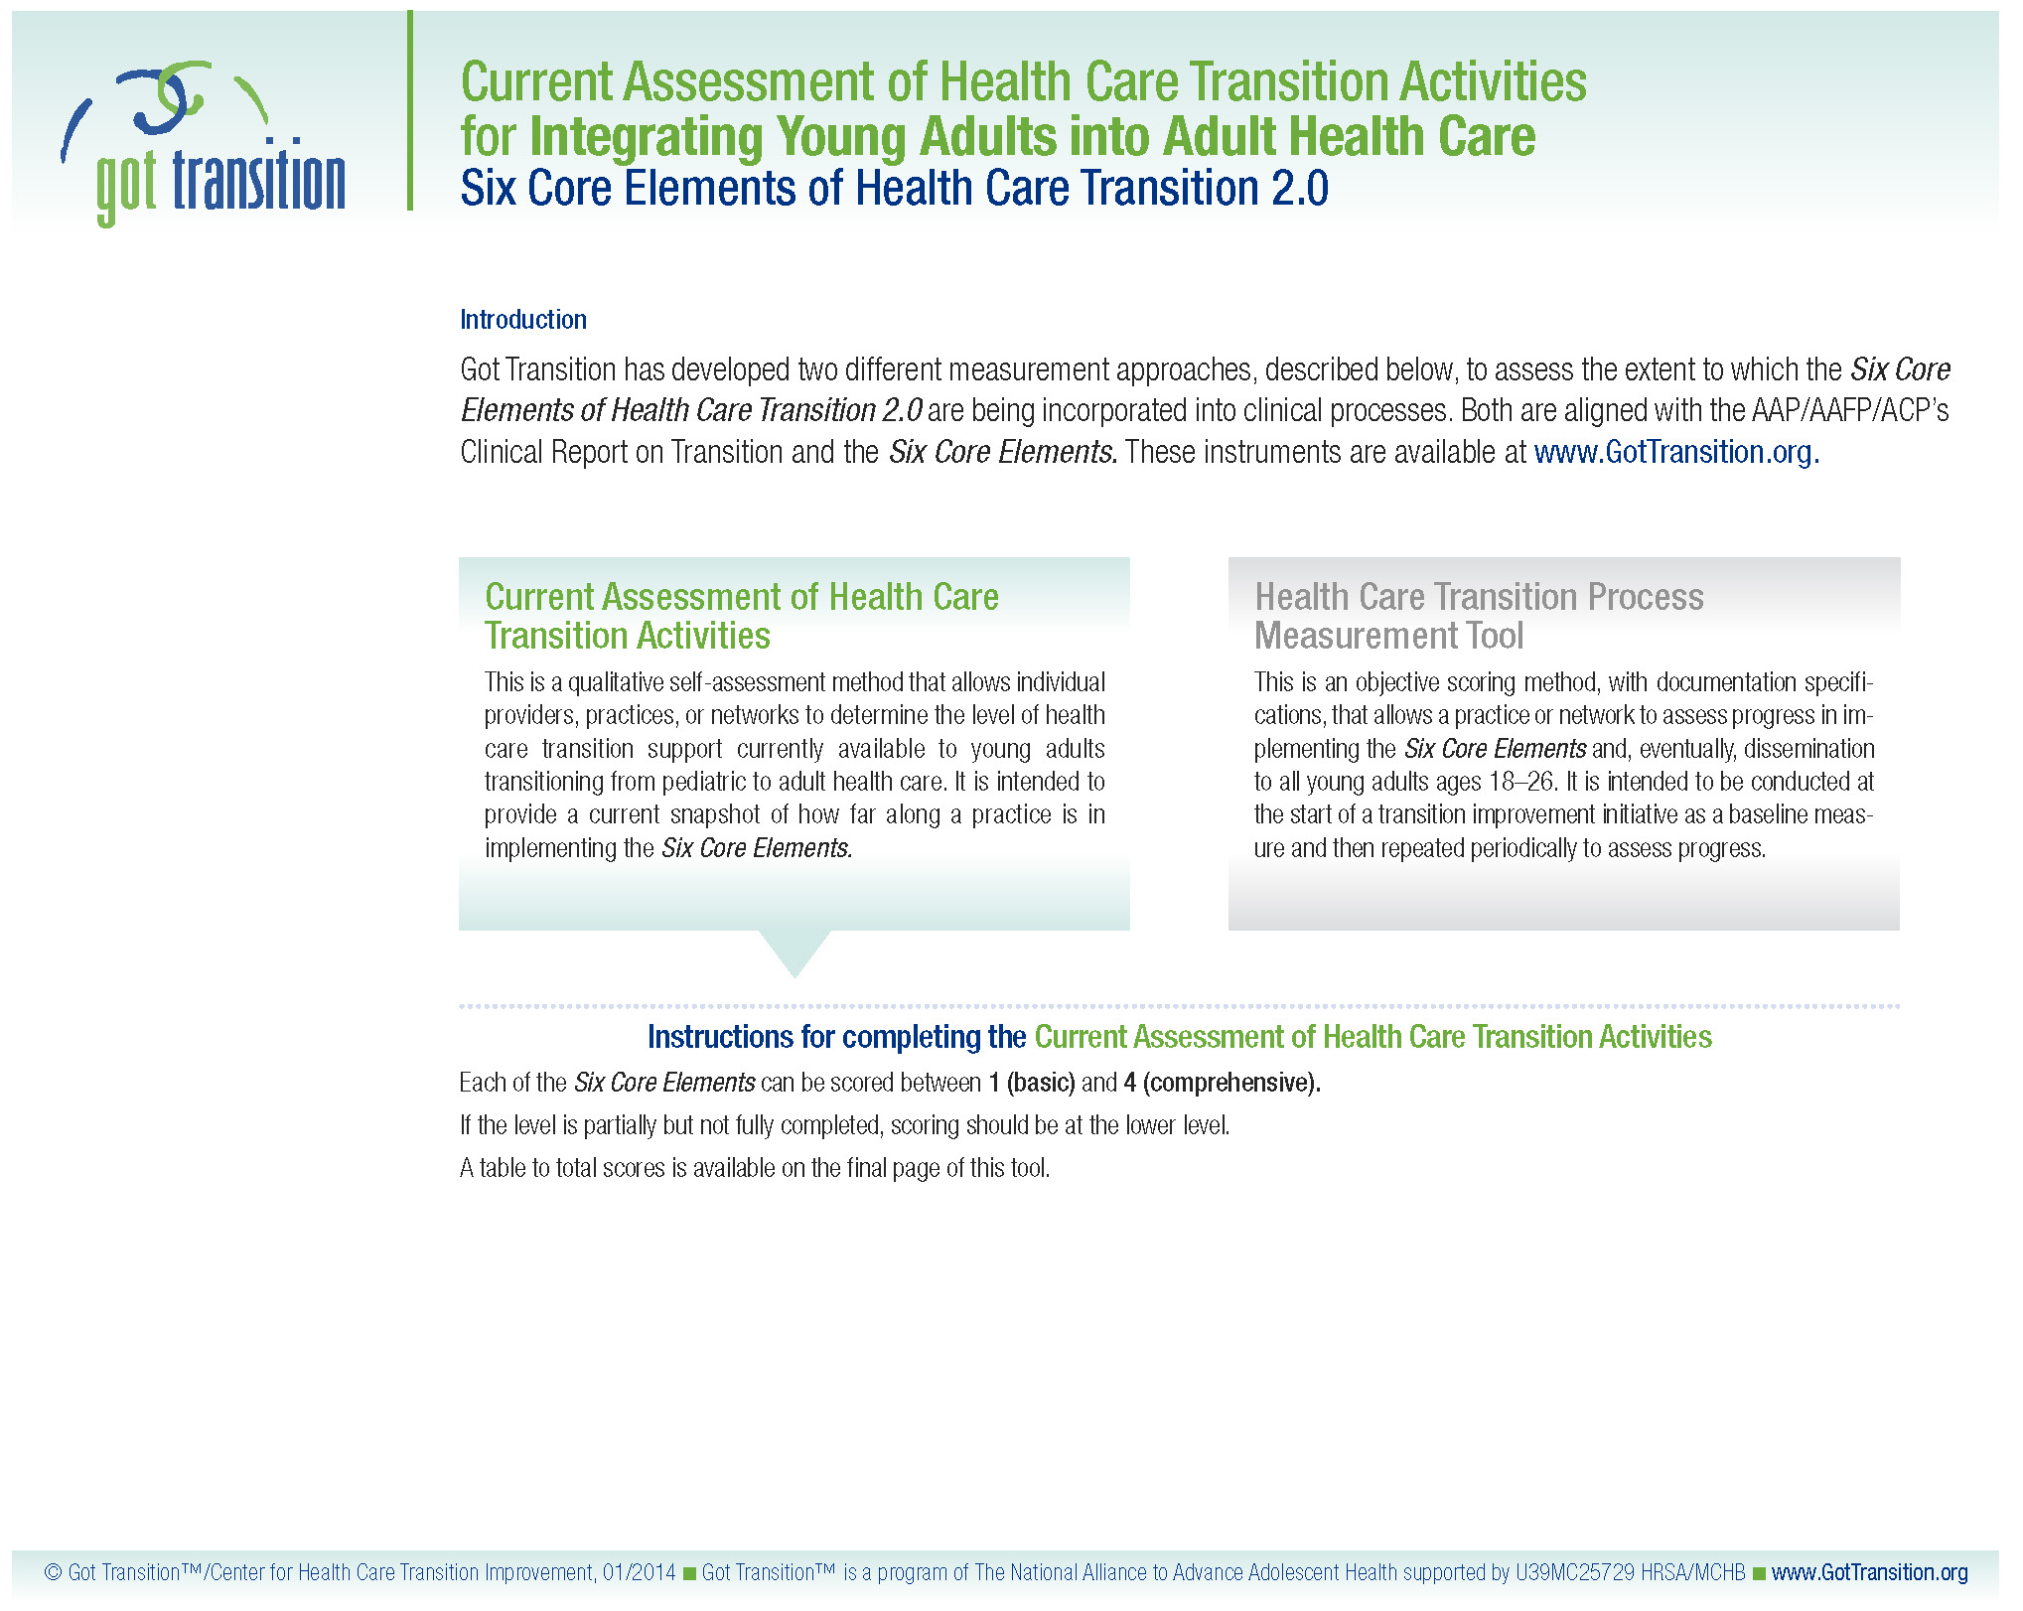

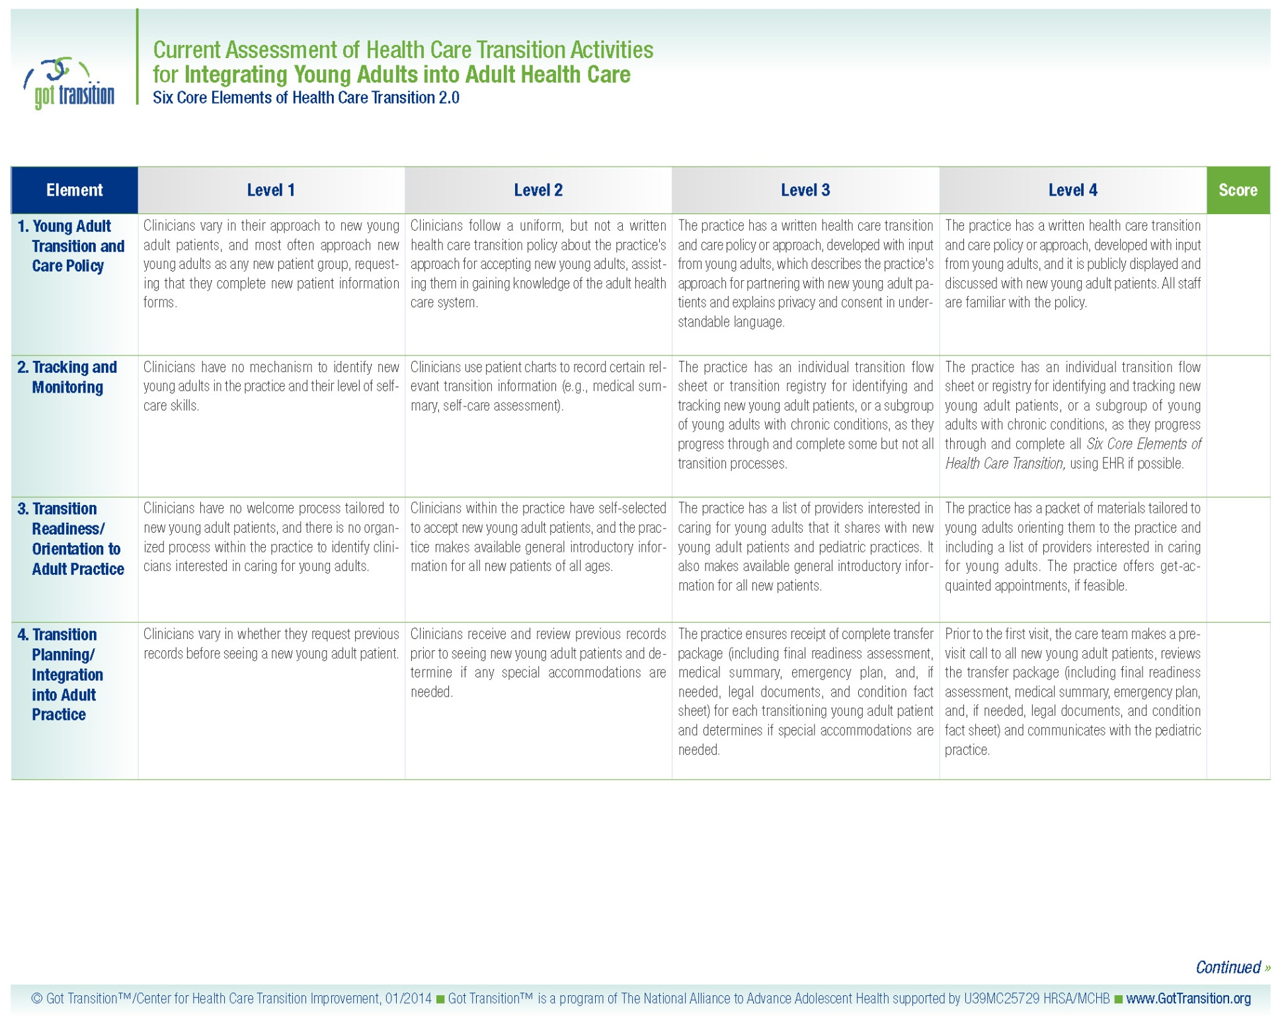

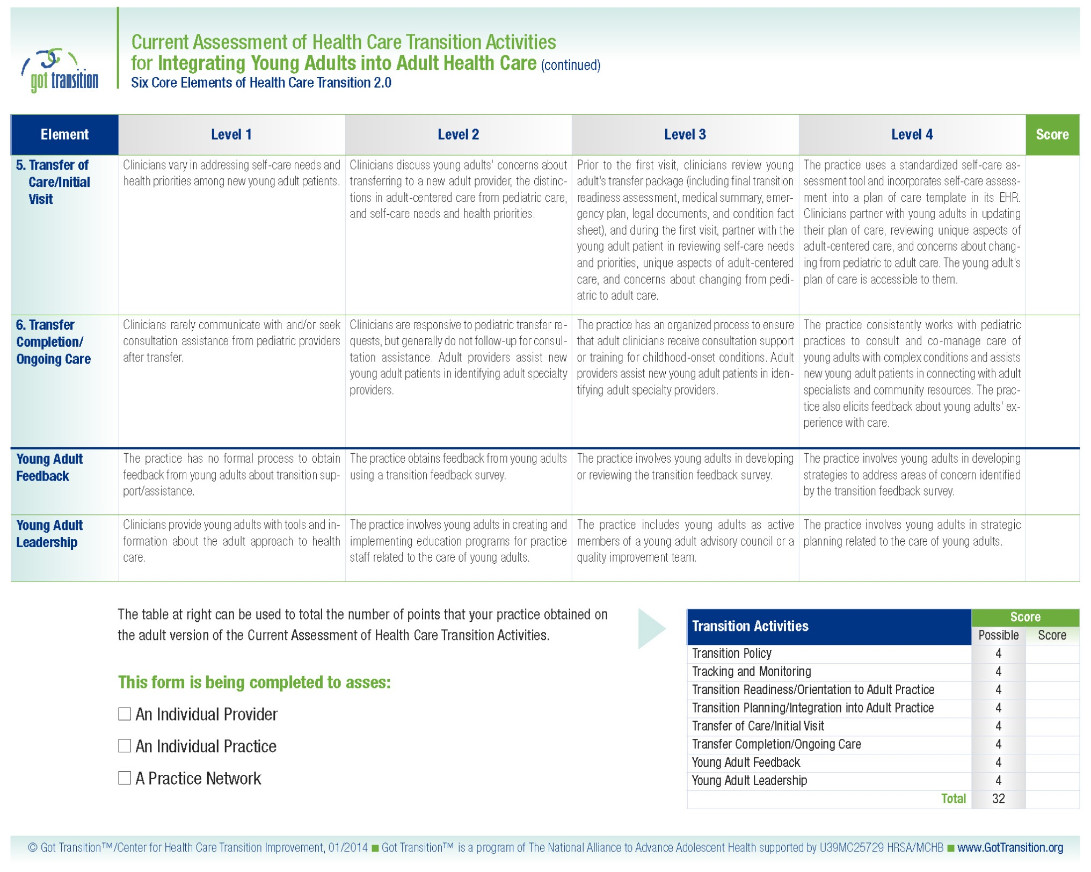

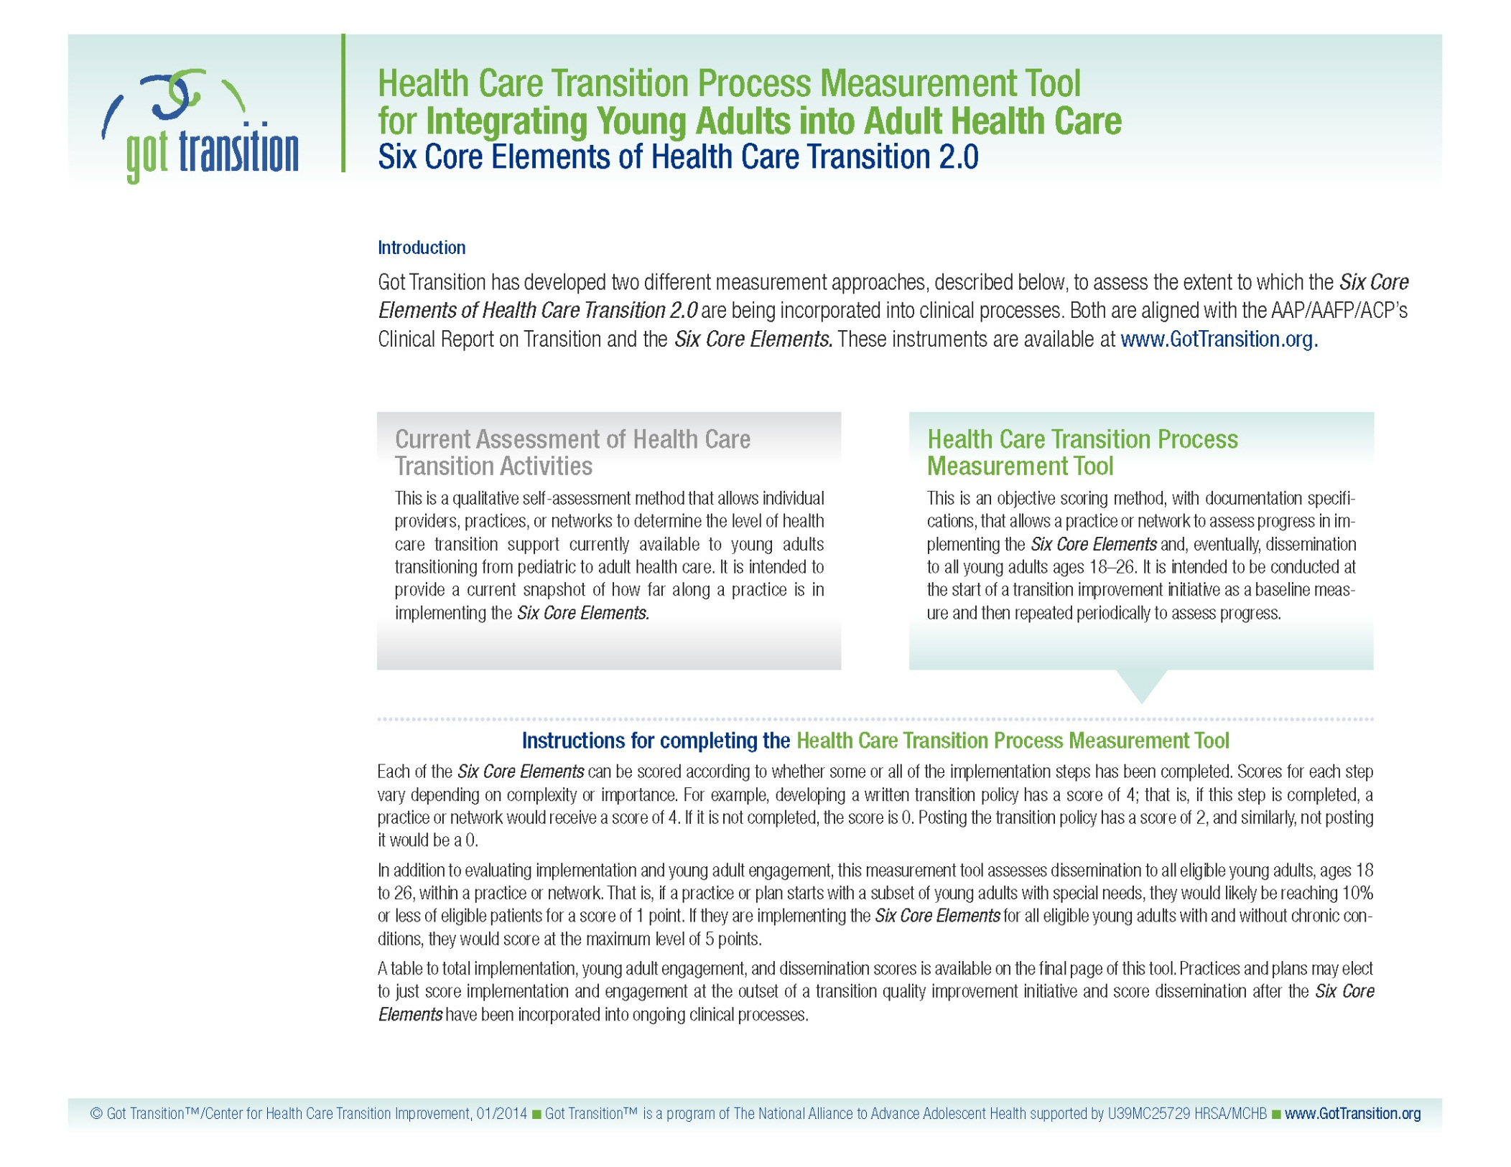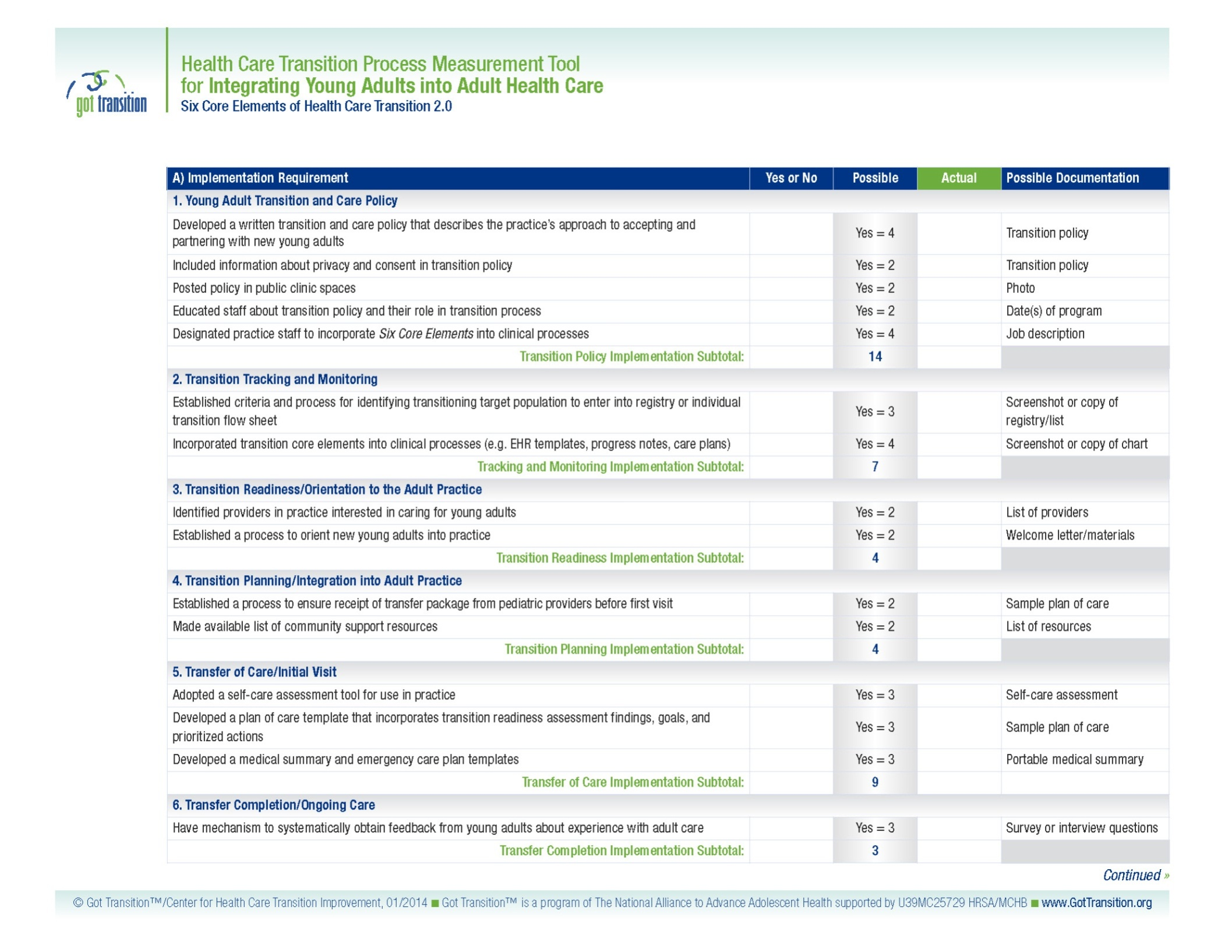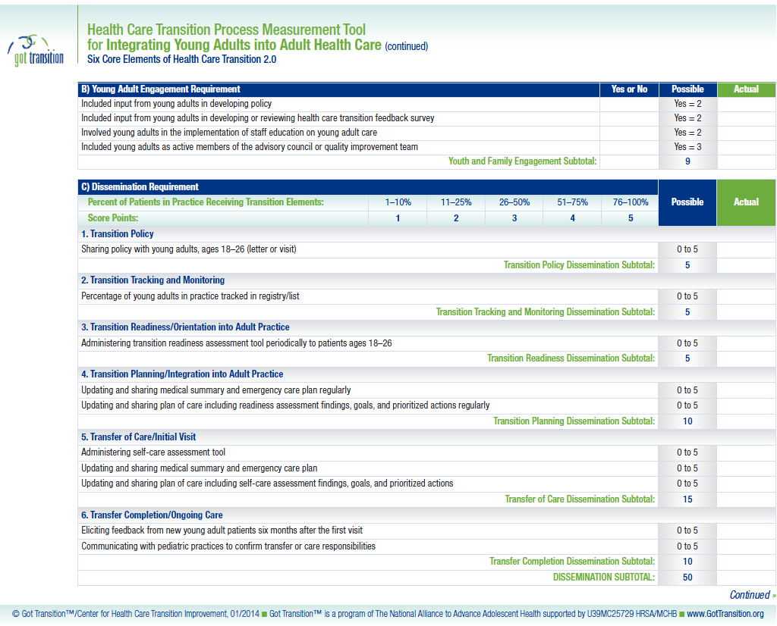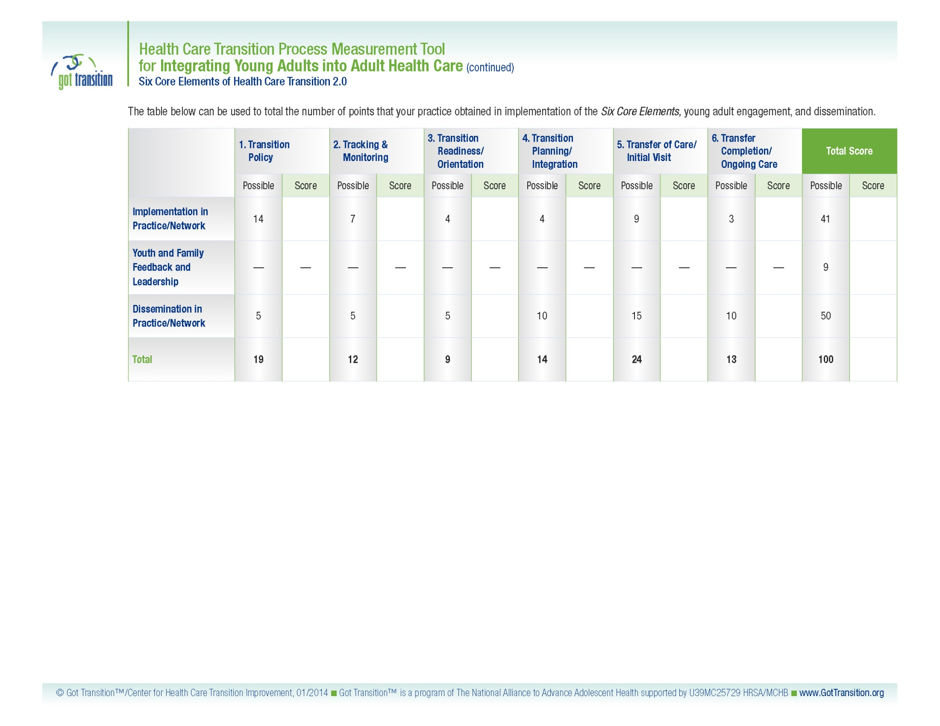

American Academy of Pediatrics, American Academy of Family Physicians, and American College of Physicians. Transitions Clinical Report Authoring Group. Supporting the health care transition from adolescence to adulthood in the medical home.Pediatrics.2011: 128; 182.
Additional information can be found at: http://www.hhs.gov/ocr/civilrights/resources/specialtopics/lep/index.htmland at: http://www.health.gov/communication/literacy/
Additional information can be found at www.thinkculturalhealth.hhs.gov
To access all three transition packages, see www.GotTransition.org.
White, PH, McManus MA, McAlister JW, Cooley WC. A primary care quality improvement approach to health care transition. Pediatric Annals. 2012: 41; 5.
Taylor MJ, McNicholas C, Nicolay C, Darzi A, Bell D, Reed JE. Systematic review of the application of the plan-do-study-act method to improve quality in healthcare. BMJ Quality and Safety. 2013:0;1.

